CLINICAL GUIDELINES FOR BREAST CANCER CONTROL AND MANAGEMENT


National Department of Health

Switchboard: 012 395 8000

Physical Address: Civitas Building
Corner of Thabo Sehume and Struben Streets
Pretoria

Postal address: Private Bag X828
Pretoria 0001

Published by the Department of Health, Private Bag X828, Pretoria, 0001, South Africa

Copyright: © Department of Health, Republic of South Africa
April 2018

www.doh.gov.za

Table of Contents
Foreword 4
Acknowledgements 5
Abbreviations and Acronyms 6
Definition of terms 8
List of tables 10
List of figures 10
1. Introduction 12
2. Key area 1: Prevention and early detection, screening and genetic assessment 14
3. Key area 2: Timely access to care 23
4. Key area 3: Assessment, diagnosis and staging 37
5. Key Area 4: Treatment of breast cancer 46
6. Key area 5: Palliative care in breast cancer 57
7. Key area 6: Follow-up and surveillance in breast cancer 63
8. Key Area 7: Data, monitoring and research 70
9. Key area 8: Community outreach and engagement 72
Annexures 74

Foreword
Breast cancer, along with cervical cancer, has been identified as a national priority in South Africa. Breast cancer is the most prevalent cancer and a leading cause of death among South African women. The increasing incidence of breast cancer is a major health concern. 19.4 million women aged 15 years old and older live at-risk of contracting the disease. Per the National Cancer Registry in 2012, 8 203 new cases of breast were observed. Given the recent advances in medicine and technology, however, we have a tremendous opportunity to attack breast cancer energetically and effectively with a revised national programme.

The Breast Cancer Clinical Guidelines is an important document aimed at providing detailed information regarding the standards laid out in the Breast Cancer Prevention and Control Policy – its companion document. These standards include awareness, prevention, and treatment and care in the South African context. It provides clinicians with the step-by-step guidance from the initial contact with the patient to the discharge back into the community. The implementation of these clinical guidelines will reduce the breast cancer related mortalities.

The clinical guidelines will also provide an opportunity to respond to the health system priorities related to cancers. It provides guidelines on the required minimum standard to establish Regional Breast Units (RBUs), including list of essential equipment, essential medicines, and personnel required. It further provides guidance on collaboration with civil society and private partners in fighting the battle against cancer.

Dr Aaron Motsoaledi
Minister of Health

Acknowledgements
The National Department of Health would like to acknowledge the irreplaceable contribution of the writing group of breast cancer clinicians responsible for the clinical guidelines. The authors of this document would like to make clear however, that any conclusions in this document and standards derived from this evidence are not necessarily the opinion of this writing group and should not be taken as such.

The contributors consisted of breast surgeons, plastic and reconstructive surgeons, oncologists, radiologists, nuclear physicians, pathologists, and geneticists. In addition, experts in the various fields, including civil society organisations and other interest groups, were also contacted when necessary for further input. The clinical guidelines provide additional context based on information that may not be available in the Breast Cancer Prevention and Control Policy. It is aligned to the health care situation in South Africa and the needs envisaged by the people of this country.

NDoH leads: Dr M Makua and Dr Y Pillay

Project Manager and Editorial lead: Mr J Tillus and Clinton Health Access Initiative

Clinical experts: Dr A Sherriff, Dr A Hoosen, Dr D Shamley, Dr T Thebe, Dr E Panieri, Dr G Demetriou, Dr J Smilg, Dr J Edge, Dr L Cairncross, Dr P Ruff, Dr S Nietz, Dr S Rayne, Dr S Cacala, Dr L Stopforth, Ms T Wainstein, Dr Z Mohamed, Dr Z Jafta, Dr R Krause, Dr I Buccimazza and Dr H Cubasch

National Department of Health contributors: Mr G Steel, Ms J Riddin, Ms D Chweneyagae and Ms S Singh

Partners and CSOs: Ms S Meyer (Cancer Alliance) and Ms L Turner (Breast Health Foundation)

Other contributors: Ministerial Advisory Committee for Cancers (MACC) representatives, Affordable Medicines representatives, Provincial Heads of Breast units, Medical Oncology units and Radiation Oncology units, Breastcare, Bettercare Books, BIGOSA and The Breast Course for Nurses

Abbreviations and Acronyms
ADH | Atypical ductal hyperplasia
ALH | Atypical lobular hyperplasia
ALND | Axillary lymph node dissection
ASR | Age standardised rate
AUS | Axillary ultrasonography
BCCCP | Breast Cancer Comprehensive Control Policy
BCN | Breast care nurse
BCS | Breast conserving surgery
BI-RADS | Breast imaging-reporting and data system
BMI | Body mass index
BPM | Bilateral prophylactic mastectomy
BPSO | Bilateral prophylactic salpingo-oophorectomy
BRCA | Breast cancer gene mutation
BRCA1 | Breast cancer gene 1
BRCA2 | Breast cancer gene 2
BCRL | Breast cancer related lymphoedema
BSE | Breast self-examination
CBC | Contralateral breast cancer
CBE | Clinical breast examination
CI | Confidence interval
CISH | Chromogenic in-situ hybridization
CMF | Cyclophoshamide, methrotrexate and fluorouracil
CNB | Core needle biopsy
CPM | Contralateral prophylactic mastectomy
CT | Computerized tomography
DCIS | Ductal carcinoma in situ
DFS | Disease free survival
DH | District Hospital
DOH | Department of Health
EDA | Emotional distress assessment
ER/PR | Estrogen-receptor/progesterone receptor
ESMO | European Society for Medical Oncology
FDG-PET | Fluorodeoxyglucose-positron emission tomography
FEC | 5-fluorouracil, Epirubicin, and cyclophosphamide
FISH | Fluorescent in-situ hybridization
FNAC | Fine needle aspiration cytology
H&E | Haematoxylin and eosin
HER-2 | Human epidermal growth factor receptor 2
HERA | Herceptin Adjuvant
HR | Hazard ratio
IDC | Invasive ductal carcinoma
IHC | Immunohistochemistry
ILC | Invasive lobular carcinoma
LABC | Locally advanced breast cancer
LCIS | Lobular carcinoma in situ
LHRH | Luteinizing-hormone-releasing hormone
LN | Lobular neoplasia
LTR | Lifetime risk
MDT | Multi-disciplinary team
MMG | Mammogram
MRI | Magnetic resonance imaging
NCCN | National Comprehensive Cancer Network
NDoH | National Department of Health
NICE | National Institute for Health and Care Excellence
OS | Overall survival
PCHCT | Palliative and hospice care team
Pcr | Pathological complete response
PCR | Polymerase Chain reaction
PET/CT | Positron emission tomography/computerized tomography
PHC | Primary Health Care
PISCBE | Provider Initiated Screening Clinical Breast Examination
PPV | Positive predictive value
QoL | Quality of life
RBu | Regional breast unit
RCT | Randomized control trial
RR | Relative Risk
RRSO | Risk reducing salpingo-oophorectomy
SBA | Specialist breast assessment
SBU | Specialized breast unit
SISH | Silver-enhanced in-situ hybridization
SLNB | Sentinel lymph node biopsy
SR | Systematic review
TRAM | Transverse rectus abdominismyocutaneous
WHO/IARC | World Health Organization/International Agency for Research on Cancer

Definition of terms
Term | Definition
Adjuvant systemic therapy | Chemotherapy, monoclonal antibodies, radiotherapy and hormonal blockade given after surgery to help decrease the risk of the cancer recurring.
Benign disease | Condition, tumour, or growth that is not cancerous. This means that it does not spread to other parts of the body. It does not invade nearby tissue
Breast care nurse | Nurse who specialises in breast care. Breast care nurses improve the continuity of care for women, and provide important information, support and referral for a wide range of needs experienced by women
Breast conserving surgery | An operation to remove the cancer and some normal tissue around it, but not the breast itself. It is also called breast-sparing surgery, lumpectomy, partial mastectomy, quadrantectomy, and segmental mastectomy
Early and locally advanced breast cancer | Early breast cancer is defined as tumours of not more than 5 cm diameter, with either impalpable or palpable but not fixed lymph nodes and no evidence of distant metastases. Locally advanced breast cancer is defined as invasive breast cancer that has one or more of the following features: may be large (typically bigger than 5 cm) may have spread to several lymph nodes in the armpit (axilla) or other areas near the breast
Emotional distress | A negative emotional reaction—which may include fear, anger, anxiety, and suffering. Breast cancer treatment can be both physically and emotionally exhausting. There are many changes taking place that may be difficult to cope with. “Chemobrain” is a term coined to describe the mental changes caused by chemotherapy treatment. Patients have experienced memory deficits and the inability to focus. Breast cancer treatments can also leave patients fatigued, which is normal.
High burden disease | Impact of a health problem as measured by financial cost, mortality, morbidity, or other indicators
Image guided core needle biopsy | Diagnostic procedure in which a core needle biopsy can be performed using ultrasonic or stereotactic guidance to confirm cancer in the breast
Lymph node surgery | Procedure whereby a surgeon operates to remove a primary cancer, one or more of the nearby (regional) lymph nodes may be removed as well
Lymphedema | Condition of localized fluid retention and tissue swelling caused by a compromised lymphatic system, which normally returns interstitial fluid to the bloodstream
Mammogram/mammography | An X-ray of the breast that is taken with a device that compresses and flattens the breast
Mastectomy | Surgical removal of one or both breasts, partially or completely
MDT | An integrated team approach to health care in which medical and allied health care professionals consider all relevant treatment options and develop an individual treatment plan for each patient collaboratively
Metastatic disease | Condition where cancer cells break away from where they first formed (primary cancer), travel through the blood or lymph system, and form new tumours (metastatic tumours) in other parts of the body
Micro-metastatic disease | Small collection of cancer cells that has been shed from the original tumour and spread to another part of the body through the lymphovascular system
Movement related pain | Pain that occurs with movement
Navigator | An individual who guides patients with a suspicious finding (e.g., test shows they may have cancer) through and around barriers in the complex cancer care system to help ensure timely diagnosis and treatment.
Neo-adjuvant therapy | Chemotherapy given prior to definitive surgery in an attempt to reduce cancer size prior to operation
Palliative care services | Approaches that improve the quality of life of patients and their families facing the problem associated with life-threatening illness, through the prevention and relief of suffering by means of early identification and impeccable assessment and treatment of pain and other problems, physical, psychosocial and spiritual
Post mastectomy radiation | Radiation therapy seeks to eradicate occult disease that remains in postmastectomy chest wall or regional nodal basins, including the supraclavicular, axillary, and internal mammary regions to reduce the risk of postmastectomy locoregional recurrence and to improve overall survival
Provincial oncology unit | Oncology unit located at a provincial-level facility
Radiation therapy | Type of cancer treatment that uses beams of intense energy to kill cancer cells. Radiation therapy most often uses X-rays.
Reconstructive surgery options | Surgical procedure that restores shape to your breast after a mastectomy
Regional breast unit | An RBU is a facility (primary or secondary) that has the adequate staffing and equipment to render the essential packages of services for prevention and early diagnosis
Sentinel lymph nodes biopsy | Procedure in which the sentinel lymph node is identified, removed, and examined to determine whether cancer cells are present. A negative SLNB result suggests that cancer has not developed the ability to spread to nearby lymph nodes or other organs
Specialised breast unit | Tertiary or quaternary with MDT capabilities
Stage 1 disease | A cancer is relatively small and contained within the organ it started in
Stage 2 disease | Tumour is larger than in stage 1, but the cancer has not started to spread into the surrounding tissues. Sometimes stage 2 means that cancer cells have spread into lymph nodes close to the tumour. This depends on the particular type of cancer
Stage 3 disease | Cancer is larger. It may have started to spread into surrounding tissues and there are cancer cells in the lymph nodes in the area
Stage 4 disease | Cancer has spread from where it started to another body organ. This is also called secondary or metastatic cancer
Synoptic histological assessment | clinical documentation method that uses structured checklists to help clinicians produce more complete, consistent and valuable medical reports
Triple assessment | Combination of three tests, i.e. clinical examination, radiological imaging (mammography, ultrasonography) and pathology used to accurately diagnose all palpable breast lumps

List of tables
Table 1: Possible outcomes of genetic testing results and implications for the individual and family 20
Table 2: Risk categorisation for screening 22
Table 3: Minimum requirement for an RBU and SBU 23
Table 4: List of Regional Breast Units by province 24
Table 5: List of Specialised Breast Units (SBU) by province 25
The signs and symptoms as outlined in Table 6 may vary from subliminal signs to limb swelling and limited limb functionality. 64
Table 7: Stages, Signs and Symptoms of BCRL 64
Table 8: Lymphedema Risk Checklist to be followed by lymphedema (LE) therapist 65
Table 9: Referral pathways for lymphedema management at all levels of care 66

List of figures
Figure 1: The High-5 Method for patient risk assessment. Source: National Department of Health South Africa 15
Figure 2: Symptomatic patient care algorithm 18
Figure 3: Algorithm for image-based screening for women who have undergone genetic testing 21
Figure 4: Spoke-Hub model demonstrating a centralised model of care for breast cancer. Until SBUs (with specialised and multi-disciplinary capabilities) can be established across the country, RBUs with linkages and coordinated relationships with SBUs must be established. Linkages between SBUs within a province and between provinces may also exist as needed. 27
Figure 5: Service requirements for a Specialist Breast Unit (SBU) 30
Figure 6 Service requirements for a Regional Breast Unit (RBU) 32
Standard 2.11, Standard 2.12, and Standard 2.13 speak to the required timeliness and quality of patient care as affirmed by medical literature and the experience of specialists in South Africa. These standards will also form the basis for evaluation of service standards during the peer review visits. The timelines of these standards are summarised in Figure 7 below. 36
Figure 8: Timeline of patient care upon presentation of breast symptoms 37
Figure 9: Breast cancer staging 42
Figure 10: Standard Operating Procedure: Integrating Nurse & Patient Navigators into breast cancer care in the Public Health Sector of South Africa 44
Figure 11: Protocol for surgery 47
Figure 12: Protocol for SLNB and ALND 48
Figure 13: SPADI Pain Domain 68
Figure 14: Quick access Early Warning System to detect upper limb deterioration: Only Pain items on SPADI 69
Figure 15: Examples of incorrect elevation of the scapula at rest and during arm abduction 69
Figure 16: Examples of an appropriate self-breast examination. Source: Groote Schuur Hospital 80
Figure 17: Example of awareness message on signs and symptoms of breast cancer. Source: National Department of Health South Africa 82
Figure 18: Example of awareness message for monthly self-examinations. Source: National Department of Health South Africa 83
Figure 19: Example of awareness message for self-breast examination. Source: National Department of Health South Africa 84
Figure 20: Example of awareness message for monthly self-breast examination. Source: National Department of Health South Africa 85
Figure 21: Example of a Z-fold information pamphlet created for the Breast Cancer Prevention and Control Policy (2017). Front. 87
Figure 22: Example of a Z-fold information pamphlet created for the Breast Cancer Prevention and Control Policy (2017). Back. 88
Figure 23: Printable copy of the High-5 method. Source: National Department of Health South Africa 89
Figure 24: Example of risk breast cancer calculator. Source: IBIS Breast Cancer Risk Evaluation Tool 91

Introduction

Background and context
- These guidelines provide additional concept of regional breast units, which was not included in the policy guidelines. This provides an opportunity for the equitable access to breast care and notes that not all breast conditions will result in breast cancer.
- The guidelines also expand on the concept of breast care nurse. This is not formally adopted by the regulatory authority (South African Nursing Council), but may refer to any professional nurse who completed the course on breast care.
- There is an accredited breast care course which is available online with intermittent face-to-face session.
- The department is working in collaboration with NGOs to develop the Breast Care course, which will be available for nurses working in public health facilities.
- This guideline also provides the concept of patient navigator, which is not a formal qualification or post but a delegation of the nurse/counsellor who will take responsibility of being a contact between the patient and the health care system.
- The guideline further introduces the provider-initiated clinical breast examination. It will require a development of on-site skills demonstration to health care workers. The National Department of Health will provide the training package and program for health care workers in PHC and district hospitals.
- The implementation of these guidelines is essential as they will form the basis of the implementation of the National Cancer Campaign in the next 3 years.

Goals and objectives

Goals:
- Improve survival
- Decrease time to presentation, diagnosis and treatment
- Decrease stage at point of treatment
- Improve quality of life in survivorship and palliation
- Effectively monitor and evaluate program implementation and the impact of breast cancer interventions

Strategic objectives:
- To improve early detection rates by promoting community awareness, and educating communities and health care workers on breast healthcare and breast cancer management.
- To facilitate referral pathways for patients with breast healthcare concerns.
- To provide guidelines for establishing appropriate facilities for the management and care of breast conditions
- To set standards for optimal care and management of breast conditions
- To provide a framework for auditing standards and outcomes

Guiding principles

GLOBAL FRAMEWORK
- South Africa recognises the United Nations’ Resolution adopted by the General Assembly on September 25, 2015: Transforming our world: the 2030 agenda for sustainable development. The development of the policy is thus guided by sustainable development goal (SDG) 3: “Ensure healthy lives and promote well-being for all at all ages”. One critical SDG target states that governments must ensure universal access to sexual and reproductive health-care services, including family planning, information and education, and the integration of reproductive health into national strategies and programmes by 2030.

NATIONAL FRAMEWORKS
      - In recognizing that health and development of the country are integrally linked, health reform in South Africa is firmly embedded in the country’s National Development Plan 2030 Our Future – make it work. The NDP aims for an inter-connectedness with the World Health Commission on the Social Determinants of Health which are considered key to any equitable health service delivery platform and includes the need to: improve the conditions of daily life, tackle inequitable distribution of power, money and resources and measure the problem, evaluate actions and expand the knowledge base (NCD DOC).
      - South Africa is in the process of introducing the National Health Insurance (NHI), in line with the National Development Plan. The NHI is a health financing system whose aim is to ensure that all South Africans have access to affordable, quality health services, based on health needs, rather than socioeconomic status. NHI importantly recognises that there is a need for massive reorganisation of the health care system to create a new platform for service provision which will also forms the basis for this policy development.

POLICIES, STRATEGIC PLANS AND PROGRAMMES
- Strategic plans for maternal, new-born, child and women’s health and nutrition (MNCWH&N) in South Africa (2012-2016), and the National Contraception and Fertility planning policy and service delivery guidelines (2012) cover other SRH priorities, and provide platforms for the implementation of the policy. All the above guidelines allow the full integration of this policy with other existing policies in the department to comprehensively address the non-communicable diseases. Integration: The policy provides synergy with other existing policy guidelines that aim to ensure universal access to sexual and reproductive health services.

Outcome focus:
- The main focus is on promoting early detection and treatment. This policy includes prevention, screening, diagnosis, treatment, care, and palliative care services. It includes the service delivery package in the community, PHC, district, regional and tertiary hospitals and private institutions.

Community engagement and involvement:
Included in the policy is the role of civil society organisations and the various ways of raising community the awareness around breast cancer.

Key area 1: Prevention and early detection, screening and genetic assessment

Standard 1.1: Women over 40 years attending a Primary Health Clinic will have a clinical breast examination (Provider Initiated Screening Clinical Breast Exams or “PISCBE”) biannually.
All women irrespective of the reason for the visit to the facility should receive provider initiated screening clinical breast examination (PISCBE). The examination should be done systematically, followed by the recording of the results. If any abnormality is detected irrespective of the severity, that woman should immediately be given a referral letter detailing the findings to the regional breast unit. Refer to Annexures for examples printed material with step-by-step instruction.

Standard 1.2: Breast care education in all primary healthcare (PHC) facilities
The opportunistic breast education will include, but not limited to, the following:

What is Breast Cancer?
Breast cancer is caused by abnormal cells in the body that grow and increase in number without stopping causing a mass. In breast cancer these cells start in the breast and can spread to other parts of the body.

Risk Factors for Breast Cancer:
- Breast cancer is very common in women and most women have no specific cause or reason for developing breast cancer
- Although women over 50 are more likely to get breast cancer, cancer can also develop in women in their 30's and 40's. Very rarely, men can develop breast cancer too
- Risk of breast cancer is higher if you have a close family member with breast cancer such as your mother, sister, daughter and all individuals mentioned in standard 1.5 of this document.
- Having a distant relative with breast cancer (grandmother, cousin, aunt, niece) will only slightly increase your risk
- Breast cancer risk is higher for women who have increased exposure to female hormones (oestrogen). Increased exposure to oestrogen occurs in women who have no children or children when they are older or women who use oestrogen containing oral contraceptives or hormone replacement therapy
- Being overweight increases your risk of breast cancer
- Lack of physical exercise
- High saturated fats in diet
- High amount of sugar in diet
- Smoking and drinking may increase your breast cancer risk

Signs of Breast Cancer:
- Breast cancer usually presents as a painless lump in the breast
- Other signs of breast cancer are:
  - A bloody or clear nipple discharge
  - Nipple retraction (pulled in)
  - Skin changes such as dimpling or swelling “orange peel”
  - Lumps under the arm (lymph nodes)
  - Scaly rash on the nipple

Breast Cancer can be Cured if Detected Early:
- It is important to know what is normal for your breasts. You may notice this when in the bath or shower or when looking in the mirror
- If you notice a change in your breast, consult your local clinic or doctor immediately to have this investigated
- Breast self-examination may help you be aware of any early changes in your breasts
See Annexure Standard 1.2 for examples of breast cancer and breast self-examination pamphlets for women.

Standard 1.3: Awareness messages should be disseminated for communities and health care workers that any woman who notices a change in breast should report to the facility.
Breast cancer is still associated with myths and stigma; and it is therefore essential that factual messages are communicated to raise awareness amongst the general public, including families and community leaders.
See Annexure Standard 1.3 examples of awareness messages.

Standard 1.4: All eligible women should have their risk of breast cancer determined and be managed according to local protocol.
During a routine 6-monthly check-up, the patient must be assessed for risk of breast cancer. The figure below demonstrates “The High-5” Method, which is an easy-to-remember set of questions that must be asked of the patient. Depending on the response to question 1, a breast exam will be conducted. As the breast exam is being done, the clinical personnel must ask the remaining four questions. The breast risk assessment must be routinely done every 6 months (Hi-5) Questions:

Figure 1: The High-5 Method for patient risk assessment. Source: National Department of Health South Africa

1
2
3
4
5

1. | Do you do self-breast exam regularly?  Yes or No
2. | Have you noticed any changes to your breast?  Yes or No
3. | Have you experience abnormal vaginal bleeding?  Yes or No
4. | Have you ever had a pap smear?  Yes or No
5. | Family history of cancer?  Yes or No

If YES is answered to any of the above questions, then follow-up with the following:
- When was your last breast exam? Pay particular attention to patients whose last exam was conducted beyond 6 months. If so, conduct clinical breast exam.
- Changes to your breast, such as a lump in breast or armpit? Use this as an educational opportunity. Look for the following items (check box):
  - Lump
  - Nipple discharge
  - Changes in colour
  - Skin changes
  - Any change in the size of the breast and/or swelling
- Do you experience any abnormal vaginal bleeding? Ask for bleeding after (check box):
  - After sexual intercourse
  - Post-menopause
  - In-between menstrual cycle
- Have you ever had a pap smear? When was your last pap smear? Were there any abnormalities communicated to you?
- Do you have a family history of cancer? Use this as an opportunity to explore further.
See Annexure 1.4 for a printable copy of the High-Five Method risk assessment form.

In case of high risk patients, clinicians can use another risk calculator index available. Annexure Standard 1.7 provides examples of risk assessment calculators.

- Women with breast symptoms presenting to any health facility (first point of contact) should have a history and breast examination performed and then should be referred DIRECTLY to either a RBU or SBU depending on accessibility
- Women at symptomatic breast clinics will present with symptoms within four identifying symptom clusters: Mastalgia, Breast Lump, Infection, Nipple Discharge and a proportion of women will be asymptomatic but concerned about their personal risk of breast cancer

- Referrals to a RBU/SBU should fall into the following referral categories:
  - Immediate Referral – to be seen at the next clinic SYMPTOMS/SIGNS suggestive of breast cancer
  - Early referral – to be seen within 21 days: SYMPTOMS/SIGNS indeterminate but may be breast cancer
  - Routine referral – to be seen within 60 days: NORMAL/ BENIGN pathology
- Determining low and intermediate and high risk clinical findings at primary level of care requires appropriate training of primary care clinicians in risk factors for breast cancer, signs and symptoms of breast cancer, the spectrum of benign breast disease and adequate clinical breast examination

Urgent referrals:
Women with the following findings on clinical examination should be referred to the Breast Clinic (preferably at an SBU) immediately and be seen at the next weekly clinic:
- Clinically suspicious breast lump (fixed, hard, irregular)
- Axillary or supraclavicular lymphadenopathy
- Skin ulceration or nodules
- Skin tethering
- Nipple retraction
- Eczematous nipple changes
- Patients with a pathological nipple discharge (spontaneous, unilateral, single duct, bloody/serous)
The following patients warrant referral to a SBU/RBU within 21 days:
- Patients >25 with a palpable breast lump
- Patients a non lactational breast infection or abscess
The following patients should be referred to an SBU/RBU within 60 days:
- Patients with mastalgia and a normal clinical examination
- Patients presenting with a concern about family history with a normal clinical examination
- Patients with lactation associated infection with non-resolution or recurrent symptoms

Figure 2: Symptomatic patient care algorithm

Standard 1.5: Referral to genetic services is offered to women whose family history meets the criteria for referral.

Eligibility Criteria for referral to Genetic Services:
Individuals who fulfil these criteria must be referred to Genetic Services for assessment and management:
- A person with breast/ovarian cancer who has any of the following:
  - Known mutation in a cancer predisposition gene (e.g. BRCA1/2, p53) in the family
  - Cancer diagnosed <40 years for breast cancer and <60 years old for ovarian cancer
  - Triple negative breast cancer <60 years old
  - Two breast cancer primaries - ipsilateral or contralateral at any age
  - ≥1 close relatives with breast cancer < 50 years
  - ≥1 close relative with invasive ovarian cancer
  - ≥2 close relatives with breast or pancreatic cancer with at least one < 60 years old
  - ≥ 1family member with male breast cancer
  - Any male with breast cancer
- A person with no personal history of cancer but with a close family history of any of the following:
  - Known mutation in a cancer predisposition gene (e.g. BRCA1/2, p53) in the family
  - Two breast cancer primaries (ipsilateral or contralateral) in a close relative at < 60 years
  - ≥3 individuals with breast cancer on same side of family with at least one ≤50 years old.
  - ≥1 individual with breast cancer ≤50 years old and ≥1 individual with ovarian cancer on the same side of the family
  - Other factors that you may take into consideration when occurring together with breast cancer: prostate cancer (aggressive type and onset <60 years), male breast cancer, pancreatic cancer, Ashkenazi and Afrikaans ancestry, other syndrome-related cancers in family members on the same side of the family.

Available Genetic Counselling & Testing Services:
Genetic Counselling for inherited breast cancer syndromes is available through the following Human Genetics Units in South Africa:
- Division of Human Genetics, National Health Laboratory Services & the University of the Witwatersrand
- Division of Human Genetics, University of Cape Town
- Department of Genetics, University of Pretoria
- Division of Molecular Biology & Human Genetics, Stellenbosch University
- Division clinical Genetics: Bloemfontein
Providers should also explore new technology and cost-effective services within the private sector.
Genetic testing for inherited breast cancer syndromes is provided by the following laboratories:
- NHLS, Braamfontein:
  - Afrikaner BRCA founder mutation testing (3 x mutations)
  - Research-based testing for multiple inherited breast cancer susceptibility genes using next generation sequencing technology.
- NHLS Bloemfontein:
  - Full sequencing and large rearrangement analysis of BRCA1 and BRCA2

Follow-Up & Management of Genetic Testing Results:
- Ideally, individuals fulfilling the criteria listed above, should be seen by a qualified genetics professional (genetic counsellor or medical geneticist) for comprehensive pre- and post-test genetic counselling.
- Management of individuals at increased risk of breast cancer owing to a genetic predisposition is ideally provided by a multi-disciplinary team including (but not limited to): a genetics professional (genetic counsellor or medical geneticist), an oncologist; a surgeon; a radiologist; a gynaecologist; a psychologist).
- Management strategies should be personalized for each patient and should a comprehensive evaluation of all available screening and prophylactic options (surgery and chemoprevention).
- The relatives of affected individuals should be targeted through cascade screening to ensure detection of additional at-risk individuals for cancer prevention interventions.

Table 1: Possible outcomes of genetic testing results and implications for the individual and family
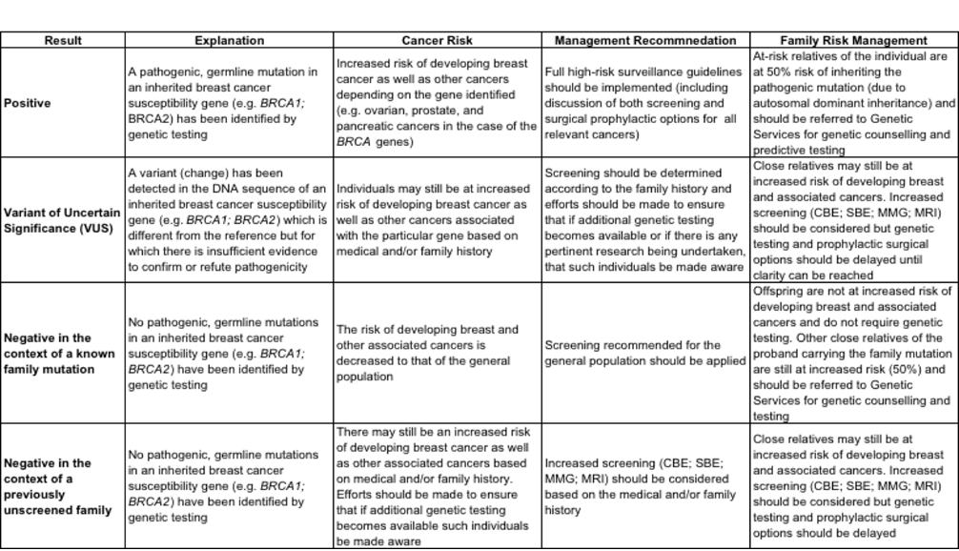

Standard 1.6: Women who are known to carry a gene mutation should have annual image-based screening with MRI.
Figure 3: Algorithm for image-based screening for women who have undergone genetic testing
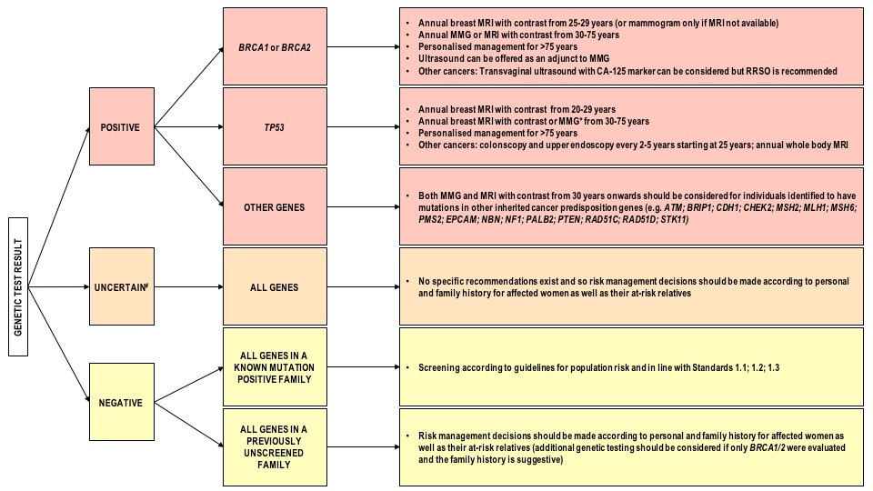
*In general, the use of MMG is discouraged in individuals who carry a pathogenic TP53 mutation. However, if MRI is not available the risk of a cancer diagnosis outweighs the risk of radiation exposure from MMG.
#A variant of uncertain significance is defined as a change in the DNA sequence of a gene which is poorly understood with respect to its contribution to disease causation. Additional research is required to classify the sequence change is either benign or pathogenic.
Other important considerations:
- This algorithm must be considered in conjunction with other risk management strategies for inherited forms of breast cancer (i.e. SBE; CBE; chemoprevention; prophylactic mastectomy; prophylactic oophorectomy; transvaginal ultrasound and CA-125 markers). The personal and family history of the at-risk individual, in addition to their personal desires, psychosocial wellbeing, and support systems should also be evaluated and considered in the decision-making process and tailoring of the risk management programme.
- This algorithm can be applied to both individuals who have not been diagnosed with cancer and those who have been diagnosed with cancer and have undergone a mastectomy as part of their treatment.
- Such considerations should be made by an at-risk individual in conjunction with a multi-disciplinary team consisting of a genetics professional (genetic counsellor; medical geneticist), radiologist, surgeon, oncologist, gynaecologist (preferably with an interest in oncology), and possibly a psychologist.
- Wherever possible, members of the MDT should make the at-risk individuals aware of the risks posed to their unaffected relatives and encourage increased awareness, referral to genetic services and increased screening availability.

Standard 1.7: Women at high risk of developing breast cancer should be considered for annual breast MRI in addition to mammography and CBE
While a variety of imaging modalities have been developed for breast cancer screening, mammography is both the best studied and the only imaging technique that has shown a mortality benefit. Ultrasonography is commonly used for diagnostic follow-up of an abnormality seen on screening mammography. It clarifies features of a potential lesion, and it may be an adjunct to mammography in women with increased breast density. Magnetic resonance imaging (MRI), performed in combination with mammography, is primarily targeted to screening in high-risk patients and not general population-based screening.
Table 2: Risk categorisation for screening
Risk Category | Lifetime Risk (%) | Screening | Age to start | Age to stop | Frequency
High Risk as determined by a risk calculator. See Annexures for examples of risk calculators. | > 30%+ | Mammography  (MRI for patients under 30 years of age can be considered)  Women with a BRACA2 mutation | 40  (or 5 years before the age at which the relative was  diagnosed with breast cancer if this calculated age is earlier than 40 years) | 70 | Annual

Risk-factors to pay attention to in the high-risk group include:
- Known BRCA mutation carriers
- First-degree relatives of known BRCA mutation carriers
- Radiation to the chest between age 10 and 30
- Genetic mutation in genes causing the Li-Fraumeni, Cowden and Bannayan-Riley syndromes

Key area 2: Timely access to care

Standard 2.1: RBUs should meet the minimum standards to provide accurate diagnosis of benign and malignant disease. SBUs should have minimum staffing and equipment to accurate treatment of benign and malignant disease.
Table 3: Minimum requirement for an RBU and SBU
Facility Type | Minimum staffing requirements | Minimum equipment requirements | Minimum equipment and service delivery package
Regional Breast Unit  (RBU) | - Surgeon in breast surgery (Clinician with appropriate qualifications or exposure/experience)  - Radiologist / Sonographer trained in breast biopsy procedure  - Anaesthetist (Qualified professional with diploma in anaesthesia)  - Pathologist  - Mammographer (2X per machine)  - Registered nurses  - Administration  - Patient advocacy representation (under nurse supervision) | - Ultrasound (spec)  - Biopsy guns and needle  - Theatre and equipment  - Teleconferencing facility  - Database  - Mammogram | - Navigation  - Counselling  - Guided biopsy  - Breast surgery (excluding complex Oncoplastic and Sentinel nodes surgery)
Specialised Breast Unit  (SBU): Tertiary hospital | - 2X Specialist surgeon with exposure (extensive – 5yrs/ 50 /year)  - Plastic Surgeon (Qualification or Exposure – experience) in Breast surgery  - Radiologist  - Mammographer  - Breast Specialist Nurse once established/ Registered oncology trained nurses  - Administrator  - Patient advocacy representation (under the supervision of nurse)  - Anaesthetist (anaesthetics diploma) –  - Pathologists  - Lymphedema specialist  - Physiotherapist  - Access to Oncologists (Medical and Radiation) | - Gamma probe  - Radiology Department with MRI, Mammogram, Ultrasound, CT Scan, Bone Scan  - Specimen mammography | - Access to oncologists (Medical and Radiation)  - Access to nuclear medicine (Bone scanner, Gamma Camera, etc.)

Standard 2.2: SBUs should allow rapid referral and access for Specialist Breast Assessment (SBA) within 1 – 62 days according to referral triage.
Open access is required at certain institutions; however as regional structures improve, appointments via referral pathways will be preferable. Nevertheless, patients should not wait longer than 62 days.

Hub and Spoke system:
Timely transition from screening and early detection to treatment (radiotherapy, chemotherapy, surgery, or palliative) is imperative for the survivorship of a patient suspected of breast cancer. And in instances of advanced disease presentation, direct referral to a SBU after passing through a RBU must be expedient and uninterrupted. Patient care is jeopardized by the lengthy pathways for continuum of care. Hindrances to timely treatment are primarily due to, but not limited, the following:
- Shortage of qualified human resource (both specialized and support) for clinical assessment, medical imaging and nuclear medicine, surgery, clinical laboratory and pathology, radiotherapy, systemic therapy and palliative and end of life care at all levels
- Availability and maintenance of medical devices and equipment
- Poor infrastructure
- Patient transport and accommodation
- Burdensome costs to the patient (and his/her loved ones)
- Disjointed referral requirements (repeated referrals for unnecessary tests, referrals to another facility or the same facility that in actuality serve as an impasse, etc.)
Given the aforementioned limitations in the continuum of care, linkages must be established in the interim between RBUs and SBUs.
An RBU is a facility (primary or secondary) that has the adequate staffing and equipment to render the essential packages of services for secondary prevention and early diagnosis. Until South Africa can establish SBUs (at the minimum) in each province, each RBU must coordinate with an SBU (tertiary or quaternary with MDT capabilities) for direct referrals. It is important to note that an RBU-SBU relationship is a contextual decision dependent on the services and capabilities available. The prerequisites for a direct referral must be agreed between the RBU and SBU. The aim is that patients who have been properly worked up and diagnosed are not overburdened by the disjointed referral pathways (for any of the aforementioned limitations) while the disease progresses. And human resource capabilities ought to be maximized at all levels.
Table 4: List of Proposed Regional Breast Units by province
Province | Proposed Regional Breast Units pending accreditation
Eastern Cape | Nelson Mandela Academic Hospital  Cecilia Makiwane Hospital
Free State | Boitumelo Regional Hospital  Dihlabeng Provincial Hospital  Bongani Regional Hospital  Botshabelo District Hospital  Mofumahadi Manapo Mopeli Regional Hospital
Gauteng | Pholosong Hospital  Tambo Memorial Hospital  Sebokeng Hospital  Kalafong Hospital
KwaZulu-Natal | Addington Hospital  Port Shepstone Regional Hospital  R.K.Khan Hospital  Ngwelezana Hospital
Limpopo | Mankweng Hospital
Mpumalanga | Emalahleni Hospital
Northern Cape | Kimberley Hospital  Upington Hospital
North West | Klerksdorp Tshepong Complex  Potchefstroom Hospital
Western Cape | Karl Bremer Hospital  Khayelitsha Hospital  Mitchell's Plain District Hospital  Paarl Provincial Hospital  Somerset Hospital  Victoria Hospital  Worcester Hospital
Table 5: List of Proposed Specialised Breast Units (SBU) by province
Province | Proposed Specialised Breast Units pending accreditation
Eastern Cape | Frere Hospital  Livingstone Hospital
Free State | Universitas Annex
Gauteng | Steve Biko Academic Hospital  Charlotte Maxeke Johannesburg Academic Hospital  Chris Hani Baragwanath Hospital  Helen Joseph Hospital  Dr George Mukhari Academic Hospital
KwaZulu-Natal | Grey’s Hospital  Inkosi Albert Luthuli Central Hospital
Limpopo | Polokwane Hospital
Western Cape | George Hospital  Groote Schuur Hospital  Tygerberg Hospital

It is envisaged that all these centres will require an accreditation process in order to ensure that they meet the minimum standards as set in this guideline (or identify the level of support required to meet the standard.)
Figure 4: Spoke-Hub model demonstrating a centralised model of care for breast cancer. Until SBUs (with specialised and multi-disciplinary capabilities) can be established across the country, RBUs with linkages and coordinated relationships with SBUs must be established. Linkages between SBUs within a province and between provinces may also exist as needed.

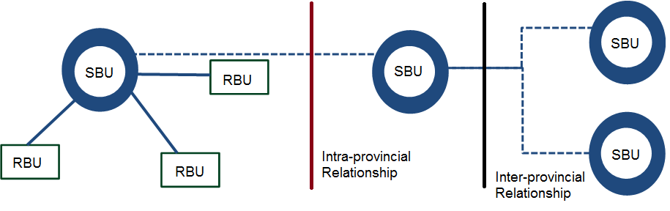
`

Standard 2.3: SBUs have multidisciplinary capability for diagnosis and appropriate management of benign breast disease.
Specialist Breast Units (SBUs) must have multidisciplinary capacity for diagnosis and appropriate management of benign breast disease and malignant breast disease. Some institutions will offer both the RBU and SBU service packages. In such instance, the diagnostic procedure will be done at the RBU level, which may be called a diagnostic clinic.

Breast clinics/Diagnostic clinics (RBU Service Package)

Diagnostic clinic
- Specialist Breast Units should run diagnostic Breast Clinics for women who are referred from primary care facilities or health practitioners with breast complaints
- These diagnostic breast clinics should over time develop into one stop diagnostic units where patients are able to access same day clinical evaluation, radiological assessment and tissue diagnosis as appropriate to each clinical scenario.
- A one-stop diagnostic model implies that after a single visit a patient may be allocated into the relevant referral pathway for malignant disease, benign disease or discharge.
- The advantages of one stop diagnostic clinics:
  - Immediate referral to oncology for malignant disease
  - Decrease in multiple clinic visits for investigation and results
  - Decrease in transport costs and loss of income
  - Increased efficiency of evaluation and discharge where appropriate
  - Alleviation of anxiety by eliminating waiting time for a diagnosis
  - Reducing loss to follow up, particularly for patients with malignant disease
- On Site Resources required for a one stop diagnostic clinic for symptomatic women:
  - Breast surgeon or Breast Clinician trained in the diagnosis of breast conditions supported by a medical and nursing team appropriate to the volume of patients seen
  - Capacity to perform FNAB and core needle breast biopsies
  - On site cytology and cytotechnologist for preliminary cytological analysis where available
  - A Breast Specialist Nurse
  - Breast ultrasound and a clinician trained in ultrasound and ultrasound guided biopsies
  - Mammography

Radiology services
- SBU must have at least one radiologist trained in breast imaging and image guided biopsy supported by an appropriate team of radiographers and administrative staff
- Mammography and ultrasound services should be resourced appropriately, proportional to the volume of benign and malignant disease seen in the SBU annually
- Mammography and ultrasound for women with signs suspicious for breast cancer should ideally be at the date of the initial visit but (in case of delay at initial visit) should not exceed 14 days thereafter
- Mammography and ultrasound for patients with clinically benign disease should be at the date of the initial visit but (in case of delay at initial visit) should not exceed 62 days thereafter
- Patients who require breast imaging as part of surveillance for gene mutations or strong family history should ideally have this done at booked intervals or within 60 days of initial visit in the context of a normal clinical examination

Management of Benign and Malignant Breast Disease at the SBU:
- After initial evaluation at the RBU (on-site/off-site), a woman with benign disease will either be discharged, undergo appropriate surgery or have a follow up appointment
- Women with malignant disease will be referred for evaluation at the MDT (see Standard 2.5)
- The MDT will make the decision regarding initial management of malignant disease (surgery, chemotherapy, hormonal treatment, etc.)

Surgical services
- SBU should have at least two specialist surgeons supported by an appropriate team of doctors, nurses and administrators to perform necessary surgery for women with benign and malignant breast disease
- Adequate theatre time must be allocated proportional to the number of breast cancer cases operated on at each SBU (100 patients per year = one full day list per week)
- This theatre time and staffing allocation must be calculated to ensure that where surgery is the first treatment modality for breast cancer, treatment takes place within 62 days of first point of contact with the health system PHC/DH or within 31 days of the decision to treat

Oncology Services
- Oncology services should be staffed with at least one oncologist supported by a team of medical and nursing practitioners
- Appropriate resources should be allocated proportional to number of breast cancer patient seen per year
- The allocation of oncology resources should be calculated to ensure that where chemotherapy is the first treatment modality, treatment takes place within 62 days of first point of contact with the health system at PHC/DH or within 31 days of decision to treat.
- Radiotherapy resources should be allocated to ensure that adjuvant treatment occurs within 60 days of surgery and no more than 90 days after surgery.

Pathology Services
- Each SBU should have at least one pathologist supported by an appropriate team and be able to fully interpret breast biopsies
- Pathology services should be resourced proportional to the number of breast cancer patients seen annually to ensure that breast biopsy results are available within ten days of biopsy
- Where available, cytotechnologists should be allocated to Breast Clinics within the SBU for immediate provisional interpretation of cytology slides facilitating early triage into benign or malignant pathways

Figure 5: Service requirements for a Specialist Breast Unit (SBU)

Standard 2.4: Regional Breast Units have direct link to MDT.
Regional Breast Units (RBU) have multidisciplinary capacity for the diagnosis of benign and malignant disease and capacity for surgical management of benign disease and basic surgical management of malignant disease once referred back from MDT evaluation at the SBU.

Regional Breast Units (RBU) have multidisciplinary capacity for the diagnosis of benign and malignant disease and capacity for surgical management of benign disease and basic surgical management of malignant disease once referred back from MDT evaluation at the SBU.

Diagnosis
- In areas where SBU’s have not been established or are geographically too far to access, Regional Breast Units should be capacitated to undertake timely and accurate diagnosis of patients with breast symptoms
- Appropriate district and/or regional hospitals should be identified for the establishment of RBU which should be capacitated to run diagnostic Breast Clinics
- These RBU based Breast Clinics should also over time develop into one stop diagnostic clinics
- On Site Resources required for a one stop diagnostic Breast Clinic for symptomatic women:
  - Dedicated allocation of an outpatient facility and regular weekly time slot in the designated regional facility (usually secondary hospital)
  - Breast surgeon or Breast Clinician trained in the diagnosis of breast conditions supported by a medical and nursing team appropriate to the volume of patients seen
  - Capacity to perform FNAB and core breast biopsies
  - On site cytology and cytotechnologist for preliminary cytological analysis where available
  - A Breast Specialist Nurse (* see appendix for description)
  - Breast ultrasound and a clinician trained in breast ultrasound and ultrasound guided biopsies
  - Mammography
- Patients who have been diagnosed with benign disease may be managed at the RBU
- Once evaluated, the following patients should be referred to the SBU:
  - Patients with confirmed malignancy
  - Patients with a clinical, radiological or pathological suspicion of malignant
  - Patients with indeterminate or uncertain results
  - High risk patients who require genetic testing or ongoing surveillance
  - Women over 55 with a breast lump
- After assessment at the SBU including surgical, oncological and MDT review, a patient may be referred back to the RBU with a recommendation for the appropriate surgery if this is within the capabilities of the RBU surgical team
- Where SBU’s and RBU’s are remote, it is possible for these MDT reviews to be done via telemedicine or an alternative distance communication platform

Figure 6 Service requirements for a Regional Breast Unit (RBU)

Standard 2.5: Mandatory multidisciplinary teams and meetings with provincial oncology units (POU)

The Multidisciplinary Team (MDT):
Description: The multidisciplinary team (MDT) model in cancer care ensures that cancer care delivery is consistent with the best available evidence. The MDT appropriately utilizes the knowledge, skills and best practice from multiple disciplines to ensure that the health care professionals together consider all treatment options and develop an individual treatment plan for each patient to reduce mortality and improve quality of life for the patient.

Approaches to MDT:
- Physical meetings
- mHealth (In regional sites, teleconferencing or videoconferencing should be considered)
- Combined

Principles:
- Discussion and decisions about the patient’s treatment options should only be considered when all relevant patient results and information are available for review and the patient has given consent for the discussion to take place.
- All patients with a newly diagnosed cancer should be discussed by the multidisciplinary team. The level of discussion may vary depending on the clinical features.
- The treatment plan for a patient should consider individual patient preferences and circumstances, and be acceptable to the patient.
- The patient should be fully informed of their treatment options as well as the benefits, risks and possible complications of treatments offered and the basis on which the MDT came to the decision(Patient's preferred support system be made part of treatment plan discussion)
- Appropriate literature should be offered to assist the patient’s decision making. This information should be made available to the patient in a form that is appropriate to their level of educational, language and culture.
- All clinicians involved in the MDT should ensure that patients have adequate information regarding regional support services and how to access this support.

The core team of disciplines should at a minimum include a surgeon, oncologists (radiation and medical oncologists), pathologist, radiologists and supportive care physicians. The team must include a breast care coordinator/nurse trained in counselling and communication.

Allied disciplines can be brought into the meeting as required and a referral network in the region should be laid out as part of the MDT working document.

Setting up a MDT:
- Should have an appointed/ delegated Breast care coordinator
This can be administrative personnel, an oncology nurse, data manager, or registrar (At larger teaching hospitals registrars may take responsibility for coordinating meetings on an alternating basis).
NB: Regardless of who fulfils this role it is important that all team members are aware of the delegation of duties with back-up if the primary coordinator is unavailable.

- Roles of Breast care coordinator
- Organizes meetings
- Identify patients for discussion during the meetings
- Collates information regarding the patient and ensures availability of relevant information sources for presentation
- Records the outcomes of the case discussions
- Informs the treating clinician and/or the patient’s referring physician of the meeting outcomes and decisions

- Meetings
- Should be held at the same time and place to maintain routine;
- The duration of the MDT meeting meetings will be determined by the size of the institution and its drainage area which defines the number of cases needing discussion.
- Must be held at a time convenient for all attendees.
- Venue should have sufficient space for all participants
- There should be access to power points for use of projectors and light boxes
.
- Records/ documentation
- Records for presentation should be made available prior to the meeting to allow for adequate preparation which includes:
  - All relevant medical history details
  - Pathology reports
  - Imaging films and scans
  - Results of diagnostic examinations
  - Blood test results
  - Previous treatment plans, if not anew presentation.

- Management guidelines
- Evidence based guidelines for care should be agreed,
- Joint protocols for clinical management, referral and audit which can provide consistency of care and standardization of treatment approach.
- There should be auditing of the meetings clinical issues and outcomes, including patients’ experiences of the service and of the availability of information for patients.

Standard 2.6: Any woman with a breast symptom will have a clinical examination and immediate referral to a designated RUB or SBU as per protocol.

Standard 2.7: Women with high or medium suspicion should have SBA within 21 days.
Standard 2.6 and Standard 2.7 are addressed together in Standard 2.2. Refer to Standard 2.2.

Standard 2.8: Women with a low suspicion of breast cancer should have SBA within 62 days.
Any woman with a breast symptom should have a clinical evaluation including appropriate history of risk factors for breast cancer and breast examination and subsequent referral to a Breast Clinic at either a RBU or SBU.

Standard 2.9: SBU must move toward an open-access model to facilitate rapid transfer and review.
Breast Clinics at RBU’s and SBU’s should move towards an open access model to facilitate rapid transfer and review.
- Open access implies that when referral criteria are met as outlined between Standards 2.6 and 2.8, women may be referred by the primary care clinician to the SBU without the administrative hurdle of making a named clinic booking
- The patient will then be advised to attend the next SBU Breast Clinic and will be seen on the day of arrival

Advantages of an Open Access System:
- Circumvents administrative delays when women are appropriately referred with symptomatic breast disease
- Ease of referral for primary care clinicians
- Early entry into the diagnostic pathway to ensure that the 62 day rule to first treatment is achievable
- Potentially decrease stage of disease as patients are seen rapidly and triaged into benign and malignant pathways early on in their management
- Potentially decrease inappropriate and inadequate investigations requested by less experienced clinicians at primary level of care e.g. repeat cytology, inappropriate imaging requests etc.
- Eliminates the risk of high risk patients waiting for several weeks for the next available booking in the SBU clinic if clinics are full/overbooked
- If the SBU clinic is overbooked when a patient physically presents to the SBU clinic in the open access model , the clinicians on site will have the necessary expertise to triage and select the high risk patients for immediate evaluation

Disadvantages of an Open Access System:
- Risk of being overburdened with referrals resulting in lack of capacity to diagnose and manage breast conditions appropriately
- Difficulties in resource planning from one clinic to the next due to seasonal and other fluctuations in referral patterns
- De-skilling of primary care clinicians in breast symptom awareness and clinical evaluation

Mitigating strategies to manage potential disadvantages of an Open Access System:
- To address these potential concerns, an open access model for SBU/RBU’s requires a functional support system at primary, secondary and tertiary level
- Adequate training of clinicians at primary level of care for the appropriate evaluation and referral of patients is critical
- A robust bidirectional communication platform between referring clinicians and the SBU is vital to ensure sustainability of an open access model
- Breast Specialist Nurses are required to facilitate oversight and streamlining of the referral pathways

Standard 2.10: Written and verbal communication should be provided at each consultation to patient.
See Annexure to Standard 2.10 for example of communication package for women with suspicious symptoms (managing scaring the patient / reducing loss to follow up) from Mitchell Plain Hospital.

Standard 2.11: Women referred to SBU with high risk of breast cancer, if diagnosis positive, should receive treatment within 62 days of first (PHC/DH) consultation.

Standard 2.12: Women with a confirmed diagnosis of breast cancer should receive their staging and first definitive treatment within 31 days of the decision to treat.

Standard 2.13: Following surgery for breast cancer, the first adjuvant therapy (chemotherapy or radiation) should occur within 60 days of surgery, and no more than 90 days.
Standard 2.11, Standard 2.12, and Standard 2.13 speak to the required timeliness and quality of patient care as affirmed by medical literature and the experience of specialists in South Africa. 31 days should be the main days. Chemotherapy must be within 31 days. Radiotherapy can be administered within 60 to 90 days. These standards will also form the basis for evaluation of service standards during the peer review visits. The timelines of these standards are summarised in Figure 7 below.
Figure 8: Timeline of patient care upon presentation of breast symptoms

Key area 3: Assessment, diagnosis and staging

Standard 3.1: All eligible patients should be diagnosed using triple assessment (clinical examination, imaging and histological confirmation)

Confirming the Diagnosis:
The following is an example of a guideline for the evaluation and management of women with breast symptoms by age category. This should serve as a broad outline with consideration given to the local clinical context and clinical findings in each individual patient.
Table 6: Approach to diagnosis and management of common breast symptoms
Age category | Breast symptoms and recommended approach
<20 years old | - Mastalgia and normal examination – reassure and discharge  - Palpable lump consistent with typical fibroadenoma (<3cm, mobile, well circumscribed) – reassure and discharge  - Large FA (>5cm) surgical excision  - Palpable lump that is not typical of an FA - breast ultrasound
20 – 25 years old | - Mastalgia with a normal clinical examination – reassure and discharge  - Patient feels a lump with a normal clinical examination – reassure and discharge  - Benign thickening / bilateral nodularity – reassure and discharge  - Palpable lump consistent with a typical FA – ultrasound  - Suspicious asymmetrical thickening – ultrasound then core biopsy  - Suspicious palpable lump – core biopsy and ultrasound
25 – 39 years old | - Mastalgia with a normal clinical examination – reassure and discharge  - Patient feels a lump with a normal clinical examination – reassure and discharge / Ultrasound only if the patient is not reassured by the normal clinical assessment or strong family history  - Benign thickening / bilateral nodularity – reassure and discharge  - Suspicious asymmetrical thickening – ultrasound then core biopsy  - Palpable lump – core biopsy and ultrasound
>40 years old | - Mastalgia with normal clinical examination – routine mammogram and discharge if normal  - Patient feels a lump with normal clinical examination – routine mammogram and discharge if normal  - Benign thickening/bilateral nodularity – routine mammogram and discharge if normal  - Routine Check-up – offer once off mammogram and discharge if normal  - Check up for family history – lifetime risk of breast cancer >17 % biannual mammogram, >30% annual mammogram  - Asymmetrical thickening/small/vague lump – URGENT mammogram then US guided biopsy  - Palpable, obvious lump – FNA/Core Bx and URGENT mammogram

Note regarding Ultrasound guided vs. Free hand biopsy: In the context of predominantly late stage disease in South Africa, biopsy of an obvious palpable mass may expedite diagnosis where imaging and image guided biopsy may prolong the interval to diagnosis and be unnecessary. Thus, where a breast lump is clearly palpable, a free hand biopsy may be done while awaiting imaging unless there is access to same day imaging. Patients with vague thickening, small or ill-defined lumps should preferably have image guided biopsies performed after urgent diagnostic imaging.

Standard 3.2: All patients completing triple assessment should have their findings discussed in a MDT meeting.
Refer to Standard 2.3, Standard 2.4, and Standard 2.5.

Standard 3.3: All eligible patients should be diagnosed using triple assessment (clinical evaluation, imaging and histological confirmation)
Refer patient to the appropriate clinical personnel at an imaging centre. Blind biopsy should not be attempted in any circumstances.

Standard 3.4: Histological assessment should be synoptic
The microscopic report of an invasive carcinoma provides information that guides treatment decisions and determines the prognosis for the patient. The use of a standardized request form for all breast tissue specimens is recommended to assist pathologists. This should include a minimal dataset provided by the clinician including: side, site, type of specimen (gauge of core/ vacuum assisted core), history, and clinical and radiological findings.

Synoptic reporting which follows a standardised format offers a systematic method of ensuring that all relevant information is included. For pathologists, synoptic reporting can improve the completeness, accuracy, and ease of creating the report. For clinicians, synoptic reports can make data extraction from the report both more rapid and more accurate.
The synoptic report can be used as the definitive pathology report or as a summary in addition to a traditional descriptive report.

A synoptic report of a core biopsy should include:
- Patient’s name. Laboratory number.
- Specimen type: core biopsy/ number and size of cores
- Location/ Laterality: left breast/right breast/not specified
- Tumour type: see below
- Histological grade 1-3 see below
- Peritumoural lymphovascular invasion: absent/ suspicious/ present/ present and extensive.
- DCIS: present/ absent; nuclear grade (low/intermediate /high); necrosis present/ absent
- Calcifications: present/ absent
- Other significant breast pathology: benign and proliferative changes. See below.
- Hormone receptor assays and other prognostic factors: ER / PR/ HER2/ Ki67. See below

Tumour type: Special type carcinomas should consist of at least 90% pure pattern
Invasive carcinoma of no special type (ductal, not otherwise specified)
- Micro-invasive carcinoma
- Invasive lobular carcinoma
- Invasive carcinoma with lobular features
- Invasive carcinoma with ductal and lobular features (“mixed type carcinoma”)
- Mucinous carcinoma
- Tubular carcinoma
- Invasive carcinoma, tubulo-lobular variant
- Invasive cribriform carcinoma
- Invasive micropapillary carcinoma
- Invasive papillary carcinoma
- Medullary carcinoma
- Invasive carcinoma with medullary features
- Metaplastic carcinoma
- Low-grade adenosquamous carcinoma
- Fibromatosis-like metaplastic carcinoma
- Metaplastic carcinoma, spindle cell type
- Metaplastic carcinoma, mixed epithelial and mesenchymal type
- Invasive carcinoma with metaplastic feature
- Squamous cell carcinoma
- Adenoid cystic carcinoma
- Invasive carcinoma with apocrine features
- Invasive carcinoma with clear cell (glycogen rich) features
- Invasive carcinoma with neuroendocrine features
- Invasive carcinoma with signet-ring cell features
- Secretory carcinoma
- Invasive carcinoma, type cannot be determined
- Other histologic type not listed (specify)

Histological grade (1-3): Elston and Ellis modification of the Bloom and Richardson grading system. This assesses the mitotic rate, tubular formation and nuclear grade. This may not be an accurate assessment of the entire tumour; but may assist in treatment decisions and prognostic assessment when complete pathological response is achieved with neo-adjuvant treatment.
- Mitosis score (1–3): calculated from the number of mitoses/ 10 high power fields
  - Score 1 (≤3 mitoses /mm²)
  - Score 2 (4-7 mitoses /mm²)
  - Score 3 (≥8 mitoses per mm²)
  - Only microinvasion present (not graded)

Tubular formation score (1–3):

Score 1 (>75% of tumour area forming glandular/tubular structures)

Score 2 (10% - 75% of tumour area forming glandular/tubular structures)

Score 3 (<10% of tumour area forming glandular/tubular structures)

Only microinvasion present (not graded)

Score cannot be determined

Nuclear Pleomorphism score (1-3): assessed by reference to normal duct epithelial nuclei
- Score 1 (nuclei small, size similar to normal breast epithelial cells, regular outlines, uniform nuclear chromatin, little variation in size)
- Score 2 (cells larger with open vesicular nuclei, visible nucleoli, and moderate variability in both size and shape)
- Score 3 (vesicular nuclei, often with prominent nucleoli, exhibiting marked variation in size and shape, occasionally with very large and bizarre forms)
- Only microinvasion present (not graded)
- Score cannot be determined

Overall Grade:

Grade 1 (scores of 3, 4, or 5)

Grade 2 (scores of 6 or 7)

Grade 3 (scores of 8 or 9)

Significant pathology features: should be documented if observed. Examples include:
columnar cell changes, intraductal papilloma, radial scars, atypical ductal hyperplasia (ADH), ALH.

Hormone receptor assay: Immunohistochemical assays of oestrogen receptor (ER) and progesterone receptor (PR) should be routinely performed on invasive breast carcinoma core biopsy specimens. Both provide independent prognostic information and predict response to hormonal therapy. In ductal carcinoma in situ (DCIS) hormone receptor status may be a predictor of response to hormonal therapy. Only nuclear staining indicates a positive result.
The following data should be included in the report
- an estimate of the percentage of nuclei stained
- the predominant intensity of staining (low, intermediate or high)
- a conclusion as to whether the assay is positive or negative.
As the receptor staining may only be available a few days after the initial report, the pathology report should include a statement that receptor status is being assessed to enable the clinician responsible to follow up.
HER2 assays: Testing for HER2 (c-erbB-2, HER2/neu) status is recommended for all newly diagnosed invasive breast cancers. It predicts the response to specific antibody therapy, and several other systemic therapies, as well as being a general prognostic marker.
Techniques for routinely evaluating HER2 status include immunohistochemistry for detecting protein overexpression and in situ hybridisation for detecting gene amplification.
Overall, 15–20% of invasive carcinomas will show HER2 protein overexpression and/or gene amplification.
Accurate assays are important because antibody therapy is costly and is associated with cardiac toxicity in a small but significant number of patients.
For immunohistochemistry:
- A negative result is 0 or 1+ staining.
- An equivocal result is 2+. In this case, in situ hybridisation testing is required.
- A positive HER2 result is 3+, uniform, intense membrane staining of > 30% of invasive carcinoma cells. In situ hybridisation confirmation should be considered if treatment with trastuzumab is planned.

Ki-67 index is strongly prognostic and is used as a surrogate marker to distinguish luminal A from
luminal B in ER+ and HER2 negative breast cancer types. It assists in treatment decisions and may serve as a predictive marker of response to neo-adjuvant chemotherapy.

Standard 3.5: All breast cancer patients should be adequately assessed for metastatic disease at diagnosis
Figure 9: Breast cancer staging

Standard 3.6: Women diagnosed with breast cancer should be screened for emotional distress

Emotional Distress Assessment (EDA)
- From the time of diagnosis, the patient with a life-threatening illness will need differing levels of support depending on their needs – physical, psychosocial and spiritual; and the intensity of the needs will change over time as the level of functioning changes and declines
- Social and psychological services should ensure address woman’s understanding of her disease, its prognosis, the complexities of treatment, her access to care, through counselling as they contribute to being major psychological and social stressors.

Common Psychosocial issues in Women with Breast Cancer
- Disruption of body image
- Fear of recurrence
- Treatment - related anxieties
- Sexual dysfunction
- Marital / partner communication
- Feelings of vulnerability

Benefits of EDA
- To support all breast cancer patients in need of palliative care support at all levels of care.
- To identify and treat anxieties caused by treatment related distress, fear of recurrence, changes in the body image and sexuality.
- To identify early psychological and social concerns of patients and enable them to obtain appropriate psychosocial services.
- To improve quality of life and high level of functioning both in the early and later years after primary treatment and in those with recurrent disease.

Standard 3.7: A named breast care nurse or counsellor should be allocated to each breast cancer patient to ensure a point of contact to the MDT.
Figure 10: Standard Operating Procedure: Integrating Nurse & Patient Navigators into breast cancer care in the Public Health Sector of South Africa

Step | Description | Activities
1 | Need for a Nurse & Patient Navigator (NPN) in breast care identified | A Nurse & Patient Navigator (NPN) Programme aims to address the following barriers to care: Psychological; Medical systems; Socio-economic; and Communication/Informational. NPNs should be placed at one or more of: The District/Regional Hospital; Hospital where oncology care is provided; and the Community (usually NPO driven). The aim is that this leads to leads to: earlier presentation: better compliance; and improved treatment outcomes.  Roles and responsibilities of:  - District/Regional Hospital(Within the specialist breast clinic):  - Patient education  - Tracking biopsy results  - Facilitating referral to the breast MDT  - Networking with other NN/PN  - Psychosocial support  - Hospital where Oncology care is provided:  - Provide patient and caregiver education  - Ongoing psychosocial support  - Assist the patient with treatment decision making  - Assist or make referrals to allied healthcare workers, not in the immediate MDT, such as social worker, dietician  - Assist or facilitate transportation arrangements when it is a barrier to care  - Track interventions and outcomes  - Contact patients where appointments are missed and  - Community – usually N.P.O.-driven
2 | Design of a pilot Nurse & Patient Navigator Project to inform scope, cost and strategy | - Design & implement Pilot NPN Programme  - Perform an impact assessment post-pilot project  - If NPN Programme deemed effective and feasible, institute roll-out at a national level
3 | Select suitable candidates for training as Nurse & Patient Navigators | An ideal candidate should have the following strengths:  - Strong interpersonal and communication skills  - Culturally sensitive  - Computer literate  - Patient-advocacy focus  - Understands hospital processes, structure and function  Design of Training Programmes:  - Training programmes specific to the local context may need to be formalised.
4 | Items to be prepared before patient contact is initiated | - Draft policies and procedures and prepare educational material.  - Both set of documents must be applicable to the local context.
5 | Periodic Assessment of the Navigational Process relative to anticipated outcomes & evaluation criteria | Anticipated Outcomes:  - Care coordination  - Efficient care delivery  - Removal of barriers to care  - Promotion of treatment adherence  - Provision of emotional support  Suggested evaluation parameters  - Numbers of patients defaulting or missing staging investigations (reasons)  - Numbers of patients missing surgery, chemotherapy or radiotherapy appointments  - Number of patients lost to follow-up  Informs improvement strategies and streamlining of the process

Key Area 4: Treatment of breast cancer

Standard 4.1: All women with early breast cancer should undergo BCS or mastectomy
Figure 11: Protocol for surgery

Standard 4.2: All patients eligible for breast conserving surgery should be offered the procedure in a centre capable of performing this
Refer to diagram in Standard 4.1

Standard 4.3: All patients with eligible axillary finding for a Sentinel Lymph Node Biopsy should be done in an SBU
Figure 12: Protocol for SLNB and ALND

Standard 4.4: All patients should have reconstruction options discussed with them in their pre-operative consultation (if appropriate)
Service may be offered where feasible and appropriate. It is not currently feasible to offer to all patients at this stage due to extreme resource limitations.

Standard 4.5: The choice of immediate or delayed reconstruction should be discussed with the MDT
Service may be offered where feasible and appropriate. It is not currently feasible to offer to all patients at this stage due to extreme resource limitations.

Standard 4.6: All patients with breast cancer should have access to adjuvant systemic therapies

Standard 4.7: Adjuvant systemic therapy, given after definitive surgery should be offered to all eligible patients
Standard 4.6 and Standard 4.7 addressed together below.

Systemic Adjuvant Treatment Post Primary Surgery:
Modified Radical Mastectomy or Wide Local Excision (WLE) plus Local Irradiation:
T1N0M0
T1N1M0
T2N0M0
T2N1M0

ER +/- PR HORMONE RECEPTOR POSITIVE:
- Luminal A (ER+ +/- PR+; Ki67 <15%; low & intermediate grade; HER2 negative)
- Luminal B (ER+ +/- PR+; Ki67 >15% +/- high grade +/- HER2 positive)

Regimen
Medicine | Tamoxifen
Route | Oral
Dose
Frequency | daily
Duration | 5 years  (May continue for 10 years, or followed by 5 years aromatase inhibitor)

Tamoxifen intolerance:
Medicine | Aromatase inhibitor: anastrazole OR exemestane OR letrozole
Route | Oral
Dose
Frequency | daily
Duration | 5 years

(Non-medical ovarian ablation (LHRH agonist not currently on EML for this indication) in high risk premenopausal patient with an AI).
For high risk disease: Consider extended endocrine therapy for 10 years.

ER +/- PR HORMONE RECEPTOR POSITIVE AND NEGATIVE:
Luminal A; Luminal B; HER2 enriched; triple negative (TNBC)

Adjuvant Chemotherapy
- Anthracycline containing regimens are preferred for node positive patients.
- Epirubicin is not recommended by NEMLC for breast cancer.
- High risk patients should receive anthracycline-taxane combination therapy.

Treatment options:

Low risk:
CMF
Medicine | Cyclophosphamide | Methotrexate | 5-Fluorouracil
Route | Oral | IV | IV
Dose | 100mg/m2 | 35-40mg/m2 | 500-600mg/m2
Frequency | Daily for 14 days | Day 1 and day 8 every 28 days | Day 1 and day 8 every 28 days
Cycles | 6 | 6 | 6

OR
AC
Medicine | Doxorubicin | Cyclophosphamide
Route | IV | IV
Dose | 60mg/m2 | 600mg/m2
Frequency | Every 21 days | Every 21 days
Cycles | 4 | 4

Moderate risk:
FAC₅₀ or AC₆₀ every 21 days x 6 cycles
Medicine | 5-Fluorouracil | Doxorubicin | Cyclophosphamide
Route | IV | IV | IV
Dose | 500mg/m2 | 50mg/m2 | 500mg/m2
Frequency | Every 21 days | Every 21 days | Every 21 days
Cycles | 6 | 6 | 6

OR
AC
Medicine | Doxorubicin | Cyclophosphamide
Route | IV | IV
Dose | 60mg/m2 | 600mg/m2
Frequency | Every 21 days | Every 21 days
Cycles | 6 | 6

High risk:
AC then paclitaxel
Medicine | Doxorubicin | Cyclophosphamide | Paclitaxel
Route | IV | IV | IV
Dose | 60mg/m2 | 600mg/m2 | 80mg/m2 (or 175-200mg/m2)*
Frequency | Every 21 days | Every 21 days | Weekly (or 3 weekly)*
Cycles | 4 | 4 | 12 (or 4)*
*if transport is difficult

OR
AC then docetaxel
Medicine | Doxorubicin | Cyclophosphamide | Docetaxel
Route | IV | IV | IV
Dose | 60mg/m2 | 600mg/m2 | 75 – 100/m2
Frequency | Every 21 days | Every 21 days | Every 3 weeks
Cycles | 4 | 4 | 4

HER2 POSITIVE*:
- HER2- enriched (ER-; PR-; HER2 positive)
- Luminal B (HER2 positive).

Adjuvant trastuzumab:
- Recommended by NEMLC
- HER2 3+ or HER2+/FISH positive
- LVEF >55%
- Patients with comorbid diseases excluded
- Excluding T1N0M0
- ECOG PS 0, 1

Clinical criteria for access to ADJUVANT Trastuzumab*
Access to be available in line with clinical criteria mentioned below, at authorised sites, prescribed by authorised prescriber (medical or clinical oncologist only).

Indication
- Early stage HER-2 positive breast cancer
- Adjuvant treatment post primary surgery
Exclusions:
- T1N0M0
- Patients with comorbid diseases especially where there is an impact on cardiac function (LVEF <55%)
- ECOG PS >2

Tests and screening
- Breast cancer tissue diagnosis (Biopsy specimen or histology of surgically resected specimen – post WLE or mastectomy)
- HER2 – 3+ OR HER2 – 2+/FISH positive
- Left ventricular ejection fraction (LVEF) evaluation: >55%
Regimen
Medicine |  | Trastuzumab
Route |  | Intravenous infusion
Dose | Initial | 8mg/kg
Dose | Maintenance | 6mg/kg
Dosing cycle |  | 3 weekly
Duration |  | 12 months

Monitoring and follow up
- 3 weekly follow up for consult and treatment (18 sessions)
- LVEF tests (4) – every 4 months

Standard 4.8: Neo-adjuvant chemotherapy or primary systemic therapy is an established option for most patients with LABC

Neo-Adjuvant (Primary) Systemic Therapy:
Neo-adjuvant systemic therapy can render surgically inoperable tumours (large T2, T3, T4 including inflammatory breast cancer tumours; N2, N3) operable.

When electing neo-adjuvant therapy, all treatment should be given prior to surgery. The tumour response should be routinely evaluated (every 2 – 3 cycles) with clinical and ultrasound examination.

If a patient with operable disease progresses or fails to respond during neo-adjuvant therapy, local treatment modalities (surgery and/or radiation therapy) must be done immediately.

Loco-regional therapy principles should be based on staging prior to neo-adjuvant therapy and in the same manner as with adjuvant therapy. There may be a greater risk for loco-regional recurrence due to suboptimal delivery of definitive local therapy.

The same chemotherapies used for adjuvant can be used neo-adjuvant with anthracycline based chemotherapy preferred.

Endocrine therapy alone (tamoxifen or AI +/- GnRH agonist) may be considered for patients with hormone receptor positive disease especially luminal A tumours.

Neoadjuvant trastuzumab is not approved by NEMLC at present.

Standard 4.9: Patients with metastatic breast cancer should be offered appropriate systemic therapy for symptom control

Systemic Treatment For Metastatic Breast Cancer:

TXNXM1:
Systemic therapy for metastatic disease prolongs overall and progressive free survival and enhances quality of life, but is not curative.

If significant bone metastases are present, an intravenous bisphosphonate (zoledronate 4mg or ibandronate 6mg) may be added 12 weekly to appropriate systemic therapy although this is not recommended by NEMLC. The renal function must be evaluated prior to and while administering bisphosphonates.

ER +/- PR HORMONE RECEPTOR POSITIVE:

If the patient had previous endocrine therapy (usually tamoxifen) within 1 year:
- Premenopausal: Chemotherapy or Ovarian ablation (GnRH agonist not currently approved by NEMLC) + AI (class)
- Postmenopausal: New line of endocrine therapy:
- Tamoxifen -> AI
- Non-steroidal AI -> steroidal AI
- Visceral crisis: Chemotherapy
- Note that fulvestrant is not recommended by NEMLC.

If the patient did not have prior endocrine therapy within 1 year:
- Premenopausal: Tamoxifen
  - Postmenopausal: Tamoxifen recommended for use unless intolerance or resistance then -> AI (class)
- Visceral crisis: Consider initial chemotherapy

HER2 POSITIVE:
Trastuzumab is not recommended by NEMLC for metastatic breast cancer

ER AND PR - ; OR ER AND/OR PR + BUT ENDOCRINE REFRACTORY:

FIRST LINE CHEMOTHERAPY
If no prior anthracycline:
- Single agent anthracycline – doxorubicin 60mg/m²
- FAC₅₀
- AC₆₀
Prior anthracycline or anthracycline contraindicated:
- Previous adjuvant anthracycline and maximum tolerance dose reached for cardiotoxicity (360mg/m² doxorubicin).
- Docetaxel 75mg/m² every 3 weeks IV
- T₆₀C₆₀₀ (docetaxel plus cyclophosphamide intravenous)
- Paclitaxel IV 80mg/m2 weekly or 175-200mg/m2 every 3 weeks if transport difficult
Frail patients including abnormal cardiac function:
- CMF (C₁₀₀M₄₀F₆₀₀) D 1 & 8 every 28 days (cyclophosphamide 100mg/m2 orally x 14 days)

SECOND LINE CHEMOTHERAPY
Docetaxel or Paclitaxel (as above if no prior taxane)
Gemcitabine 1g/m2 D 1,8,15 every 28 days
Gemcitabine 1g/m2 D 1,8 + platinum D1 every 21 days (especially TNBC)
- cisplatin 60-75mg/m² if eGFR >60ml/minute or carboplatin AUC 5 if <30-59ml/minute
- avoid carboplatin if bone marrow function impaired
Vinorelbine 25-30mg/m² D 1 & 8 every 21 days (may need port insertion as risk of extravasation)
Capecitabine orally 850mg/m2 12 hourly x 14 days every 21 days is not recommended by NEMLC due to cost but should be reevaluated due to recent advent of generics.

THIRD LINE CHEMOTHERAPY

Gemcitabine 1g/m2 D 1,8,15 every 28 days
Gemcitabine 1g/m2 D 1,8 + platinum D1 every 21 days (especially TNBC)
- cisplatin 60-75mg/m² if eGFR >60ml/minute or carboplatin AUC 5 if <30-59ml/minute
- avoid carboplatin if bone marrow function impaired
Vinorelbine 25-30mg/m² D 1 & 8 every 21 days (may need port insertion as risk of extravasation)
Capecitabine orally 850mg/m2 12 hourly x 14 days every 21 days is not recommended by NEMLC due to cost but should be reevaluated due to recent advent of generics.

SUPPORTIVE TREATMENTS:
HIGHLY EMETOGENIC CHEMOTHERAPY (HEC)

Doxorubicin +/- IV cyclophosphamide; cisplatin
PRE-THERAPY | Ondansetron 8mg IV  PLUS  Dexamethasone 16-20mg IV

DELAYED EMESIS | Olanzapine, oral 5mg daily for 5 days
DELAYED EMESIS | Note: aprepitant is not recommended by NEMLC

Moderately emetogenic chemotherapy (MEC)

IV cyclophosphamide; carboplatin
PRE-THERAPY | Ondansetron 8mg IV  PLUS  Dexamethasone 16-20mg IV

DELAYED EMESIS | Olanzapine, oral 5mg daily for 5 days
DELAYED EMESIS | Note: aprepitant is not recommended by NEMLC

Mildly emetogenic chemotherapy

Gemcitabine; 5-fluorouracil, methotrexate
PRE-THERAPY | Ondansetron 8mg IV  OR  Metoclopramide 10mg IV

Taxanes:

Paclitaxel infusion reactions | On day 0 (evening):  Dexamethasone, oral 8mg nocte  OR  Prednisone, oral 40mg nocte  On day 1 (morning):  Ranitidine 50mg IV OR Cimetidine 300mg IV  PLUS  Promethazine 6.25 – 12.5 mg IV
Docetaxel infusion reactions | On days 0, 1, and 2:  Dexamethasone, oral, 8mg daily  OR  Prednisone, oral, 40mg daily

Vinorelbine IV

Extravasation | Cimetidine 300mg IV  PLUS  Hydrocortisone 100-200mg IV

Trastuzumab

Infusion Reactions | Promethazine 6.25 – 12.5 mg IV

Capecitabine:

Hand-foot syndrome (HFS) | Lanolin based cream

Hot flashes

Hot flashes | Clonidine 0.1mg daily  Venlafaxine 37.5-75mg nocte  (or other SSRI or SNRI recommended by NEMLC)

Standard 4.10: All patients suitable for surgery or adjuvant radiation referred for treatment within 42 days of referral following MDT decisions
Workup procedure must be completed by the referring institution. Refer to National Policy Framework and Strategy on Palliative Care.

Standard 4.11: Radiation should be offered to all patients after breast conserving surgery within 90 days
Workup preparation must be completed at the treating institution.

Standard 4.12: Post-mastectomy radiation should be offered in high-burden of disease within 60 days

Indications for radiotherapy:

Loco-regional treatment of clinical Stage I, IIA, IIB and IIIA
- > 4 positive axillary nodes: Radiation therapy to whole breast with or without boost to tumour bed, infraclavicular region, supraclavicular area, + internal mammary lymph nodes and any part of the axillary bed at risk. The radiation therapy is to follow the chemotherapy when indicated.
- 1-3 positive axillary nodes: Radiation to the whole breast with or without a boost to the tumour bed. Also advised radiation therapy to the infraclavicular region, supraclavicular area, + internal mammary lymph nodes and any part of the axillary bed at risk.
- Negative axillary nodes and a tumour >5cm or margins positive: Radiation therapy to the whole breast/chest wall with boost to the tumour bed, infraclavicular region, supraclavicular area, + internal mammary lymph nodes and any part of the axillary bed at risk.
- Negative axillary nodes and tumour < 5cm and negative margins: Radiation therapy to the whole breast/chest wall with or without boost to the tumour bed.
- Negative axillary nodes and tumour < 5cm and margins > 1mm: Radiation could be omitted if no other high risk recurrence factors (close margins, tumous > 2cm premenopausal, and lymphovascular invasion
- If a T2 or T3 tumour fulfils the criteria for breast conserving surgery, except for the size, then neo-adjuvant systemic therapy can be considered

Standard 4.13: A written local protocol for radiation should be disseminated by POU to all referring MDT and SBUs and RBUs

Principles of Radiation therapy
- This treatment is initiated and managed by Radiation Oncologists on tertiary level
- Target delineation is best achieved by the use of CT based simulation and planning.
- Radiation planning and delivery should be individualized.
- Target dose homogeneity (as per ICRU 62 and 83) and sparing of normal tissue (for the lungs, spine, skin, heart and brachial plexus as per QUANTEC guidelines)
- Verification of the daily setup consistency is done with weekly imaging.

Whole breast radiation (4.11)
- The target is the entire breast tissue, the whole breast should receive 46-50Gy in 23-25 fractions or 40-42.5Gy in 15-16 fractions. 5 fractions/week.
- Hypo fractionation is preferred based on the START trials. Lancet Oncol 2013; 14: 1086-1094
- A boost to the tumourbed is recommended for patients with a high risk of recurrence: Age < 50 years, high grade disease, focally positive margins, positive nodes
- Boost dose: 10-16Gy in 4-8 fractions with either conventional fractionation schedule or hypo fractionation. The boost is usually delivered with electrons or photons.

Chest wall radiation (including breast reconstruction) (4.12)
- The target is the ipsilateral chest wall, mastectomy scar, and drain sites.

Regional Nodal Radiation
- Two studies, MA.20 and EORTC 22922/10925 evaluated the addition of radiation to the internal mammary nodes and the upper axillary nodes including supraclavicular area to the whole breast radiation/chest wall after lumpectomy or mastectomy. Reduced local recurrence, improved DFS and decrease in distant metastasis were found.
- If regional nodal radiation is indicated and a hypofractionation schedule is followed the START B is indicated with 2,67Gy x 15 fraction to a total dose of 40.05Gy.

4.11 Radiation in patients whom received neo-adjuvant systemic therapy
- The decision on radiation should be based on the maximal stage, tumour characteristics and pathological stage prior to systemic therapy.
- Adjuvant radiation is delivered after completion of adjuvant chemotherapy (Upfront-Outback trial) , adjuvant Trastuzumab should be given concurrently with adjuvant radiation.

Key area 5: Palliative care in breast cancer

Standard 5.1: Palliative care services should be available to every eligible patient.

Standard 5.2: In collaboration with palliative care services, nursing professionals specific to palliative breast cancer care in SBUs/POUs can provide basic palliative care.
Standard 5.1 and Standard 5.2 are addressed together below.

Palliative care is a multidisciplinary approach to the holistic care and support for patients and families facing a life-threatening illness, improving quality of life while maintaining dignity from the time of diagnosis until death. The goals and objectives have been developed based on the WHO health system building blocks for health services.

The national policy framework and strategy for palliative care serves to provide guidance and a framework within which to plan for the strengthening and implementation of palliative care services in South Africa.
Palliative Care is to be provided for patients who have been diagnosed with a life threatening illness for which cure is not possible and who have significant symptoms – physical, psychosocial or spiritual.

The World Health Organization (WHO) describes palliative care as services designed to prevent and relieve suffering for patients and families facing life-threatening illness, through early management of pain and other physical, psychosocial, and spiritual problems.

Purpose
To improve the quality of life, well-being, comfort and maintain human dignity for individuals, through an age appropriate health service that values patients’ need to receive personally and culturally sensitive information on their health status, adequate relief of suffering in physical, psychosocial and spiritual domains of care, while acknowledging their central role in making decisions concerning treatment.

Responsibilties
Palliative care is best provided by a multi-disciplinary team which includes health workers and allied health professionals and social workers.

From the time of diagnosis, the patient with a life-threatening illness will need differing levels of support depending on their needs – physical, psychosocial and spiritual; and the intensity of the needs will change over time as the level of functioning changes and declines.

Procedure
Model of palliative care: Different local needs will require different models of palliative care service delivery.
- Home based Palliative Care: A palliative care service provided by professionals and lay caregivers in patients’ homes. Physical, psychosocial and spiritual care is offered. This consists of regular palliative assessment by a suitably qualified nurse, who supports the family and lay caregivers. Essential palliative care medicines are available for use
- Mobile Outreach services: A mobile palliative care team visits remote health facilities linked to the parent health facility, to see patients who cannot travel long distances to access care
- Outpatient Care: Palliative care is offered for ambulatory patients at clinics. Either a specialised palliative care team or health care workers at a clinic can provide palliative care
- Inpatient palliative care facility: A specialist palliative care inpatient unit for the management of symptoms and pain unmanageable at home, as well as for respite care and for terminal care where death in the home is undesirable. The focus is on comfort which is different to that of an acute hospital ward
- Hospital based palliative care teams: A consultative palliative care service provided by a specialist fully multidisciplinary palliative care team. The patient remains the responsibility of the admitting and treating team, but is supported by the palliative care team
- Day Care Palliative services: Ambulatory patients spend one or more days at a centre, which may be independent or attached to another service (e.g. a hospital or a clinic). Programmes may be offered to assist patients and families with coping with the illness, Occupational therapy or skills training may be offered. Counselling and medical services are usually available. The day care is often supported by volunteers
- Frail Care and other care homes: Palliative care is offered in frail care and other care homes, either by a specialist team which may visit or by in house staff who have been trained in palliative care
- Workplace programs: Palliative care programs to provide bereavement support and information about palliative care. The programs are often initiated by the employer with support from palliative care professionals for any information or therapeutic interventions
- Correctional services Palliative care services provided within correctional facilities either by the health care professionals within the facility or by visiting palliative care professionals

Who is in need of the Palliative Services?
According to the South African palliative care screening tool, CANCER as one of the illnesses that is identified as needing palliative care service.
If any of the following criteria below if fulfilled, the patient may be in need of palliative care interventions and a more detailed assessment of need should be performed
- Decreasing activities of daily living
  - In bed for >50% of the day
  - Increasingly relying on others for self care (bathing/dressing/eating)
  - Incontinence
- Has had repeated unplanned hospital admissions in last 6 months/1 year
- Multiple co-morbidities (co-existing illnesses) with complex problems
- Losing weight unintentionally between past 3 and 6 months/ clothes getting too big/ >10% unintentional weight loss/muscle wasting
- Losing appetite
- Has had a serious fall
- Becoming confused
- Patient or family request change in goals of care, i.e. withdrawing active interventions
- Is experiencing serious social difficulties as a result of the illness
- Advancing disease – which is unstable and deteriorating

Who provides palliative care?
According to the SA’s National Palliative Framework Strategy on Palliative care, Social and Social Auxiliary worker and psychologists form part of the multidisciplinary teams at ALL levels of care including the following:
- Doctors
- Allied Health Workers
- Nutritionists

Main aim
The main aim of palliative care is to relieve pain and other symptoms. Pain is viewed as multidimensional total pain which is experienced as physical, emotional, psychosocial, cultural and spiritual. All of these aspects of a person’s life need to be addressed to relieve pain and suffering.

Timing for palliative care
- Palliative care is to be available from conception to death across the continuum of care.
- From the time of diagnosis, the patient with a life-threatening illness will need differing levels of support depending on their needs – physical, psychosocial and spiritual; and the intensity of the needs will change over time as the level of functioning changes and declines
- There is evidence that early palliative care, from the time of diagnosis of a serious condition, improves a patient’s quality of life, reduces depression and may even have the capacity to prolong life.
- Palliative care services are available at all levels of care from the point of diagnosis using appropriate clinical tools, and should be made available from tertiary hospitals through to community based care.

Responsibilities
Their responsibilities form part of the packages of care for palliative patient, but differ according to the patient level of functioning:
ECOG (0 -2)
- Counseling – patient and family
- Education - patient and family
- Access to social grants as needed
ECOG (3) Unable to work. Spending >50% of day in bed. Needing more assistance with self- care
- Ongoing Counseling and education
- Social grants
ECOG (4) Bedbound. Needs full assistance with self- care
- Ongoing counseling and education for patient and family
- Support through the dying process
- Social grants
ECOG (5) Death
- Bereavement counseling and support for family

Tertiary Hospital Palliative care specialist teams (Specialised, regional)
- Will consist of at least 1 specialist palliative care doctor (preferably 2), at least 2 palliative care nurses and 1 social worker, depending on number of beds to be serviced.
- These teams would have specialist qualifications (Masters level or greater) in palliative care
- Dedicated to rendering will provide consultancy services within the tertiary hospital and the regional referral network to regional and district hospitals.
- Medications include Morphine available oral IR, oral SR, parenteral (syringe drivers, IVI), and other specialist level palliative care medicines

District Palliative Care Team
- 1 doctor with Generalist Palliative Care (GPC) training and 1 GPC nurse + other nursing staff
- Palliative care Doctor and palliative care nurse to have postgraduate training in palliative care at diploma level or equivalent
- In addition to other clinical responsibilities, this team will manage patients requiring palliative care either in external Sub-Acute facilities or within district hospitals and to provide support to the community based palliative care services
- Medication include: Morphine available, oral IR, oral SR, parenteral (syringe drivers), and essential palliative care medicines

Community palliative care services – Clinic level
- Nurses and doctors in clinics to manage patients utilizing the palliative care approach
- Nurse, doctor and counselors with basic palliative care skills.
- Identification and management of basic palliative care needs of patients as part of normal patient care
- Referral to social services (social workers and social auxiliary workers) as required and referral to district hospital as needed for more complex needs
- Medication include: Morphine available, oral IR, oral SR
- Parenteral morphine at CHCs and essential palliative care medicines

Community Based Palliative Care Services - community
- Community Health Workers (CHW) and Home Based Care (HBC) teams with a nurse team leader caring for patients at home, in NGO’s and in hospices
- Lay health care workers trained in the palliative care approach
- CHWs identify and refer patients needing palliative care.
- HBC are caregivers for patients and families
- Under supervision of nurse team leader, they refer to Social Services (Social workers and Social auxiliary workers) or clinic as required
- Medications include: Access to essential palliative care medicines and morphine:
- Collect at local clinic (dispensed from a hospital on named patient basis

Procedure

Community Based Palliative Care (Home Care)
- Patients identified as needing palliative care may receive such care at home
- A mobile patient with few needs would be able to attend an outpatient clinic monthly or weekly
- When functional status declines, patient would benefit from a monthly/weekly home visit by a nurse supervised by a doctor who may need to visit the patient at home.
- A totally bedbound patient may need more frequent, weekly visits from a nurse and a daily home based caregiver to assist with activities of daily living

Clinics CHCs and PHCs
- Patients who are ambulatory and able to travel, will access palliative care services at a clinic. Clinic staff is trained in basic palliative care. Should a problem not be resolved, a specialist palliative care team at the relevant referral hospital should be consulted

Hospital – District to tertiary level
- Patients may be identified in the wards or at the outpatient clinics at the hospital as being in need of palliative care
- A specialist palliative care team comprising a doctor, professional nurses and a social worker will offer specialist services with staff members trained in specialist palliative care (postgraduate diploma)
Resources and consumables required to provide palliative care services at different levels of care

Referral Pathway
A patient may be identified at any level of the health care system as needing palliative care and will need to be referred to the appropriate level of care, which may be down-referral from hospitals to clinics or to home for ongoing care or up-referral from clinics to hospitals for more specialist level palliative care interventions

Tertiary hospital
The patient is identified by the primary care team as having palliative care needs, using an appropriate palliative care tool. Primary team initiates palliative care and consults with specialist palliative care team if specialist care is required

District hospital
Palliative care is initiated by the hospital team in the ward. All health care workers in a district hospital should have sufficient knowledge to apply palliative care principles and to offer adequate palliative care services. Should they encounter a problem that cannot be adequately addressed, a specialist palliative care team at the referral secondary or tertiary hospital should be consulted for assistance.

Clinic
A patient is identified at the clinic as needing palliative care or a patient is referred from a hospital for ongoing palliative care in the community. Staff at the clinic is trained in basic palliative care. Should there be a problem that is too difficult to address at clinic level, the specialist palliative care team at the relevant referral hospital is consulted
A patient is identified as needing palliative care by the community health worker or DST, or the patient is referred to the community care teams from the clinic. The CHW has basic training in identifying a patient who may need palliative care. The nurse and doctor have basic palliative care training.

Delivery of palliative care is as follows:
- Packages of care related to the level of functioning
- For patients with cancer who have high symptom burden and/or unmet physical or psychosocial needs, outpatient palliative care programs should deliver palliative care services to complement existing program tools.
- For patients with early or advanced cancer who will be receiving care from family caregivers in the outpatient setting, providers (e.g. nurses, social workers) may initiate caregiver-tailored palliative care support, which could include telephone coaching, education, referrals, and face-to-face meetings.
- Social workers will interact with caregivers who may live in rural areas or are unable to travel to the clinic.
- All cancer patients should be repeatedly screened for palliative care needs, beginning with their initial diagnosis and thereafter at intervals as clinically indicated
- Palliative care should be initiated by the primary oncology team and then augmented by collaboration with palliative care experts.
- All health care professionals should receive education and training to develop palliative care knowledge, skills, and attitudes
- An interdisciplinary team of palliative care specialists should be available to provide consultation or direct care to patients and/or families as requested or needed

Role of Radiation in the metastatic patient
Palliative Radiotherapy for the following:
- Skeletal metastasis to address pain: 3Gy x 10; 4Gy x 5
- Skeletal metastases for cord compression: e.g. 3Gy x 10; 8Gy x 1; 4Gy x 5
- Local breast tumor ulcerating, bleeding: e.g. 3Gy x 10 – 15; 6Gy weekly x 5
- Brain Metastases, e.g. 3Gy x 10; 4Gy x 5

Supporting the Carer
Social and psychological services are needed to support the care of the carer program.
Caring for a patient with palliative care needs can be emotionally and physically exhausting.
All those providing care, family members, friends and care workers, both professional and lay, need access to some form of support either through regular support groups or by one-to-one counseling sessions, to prevent “burn-out”.
- Stress management skills to be taught
- Improve or adjust working environment
- Sharing of responsibilities with other carers or family members
- Professional and emotional support
- Bereavement counselling
- Establish support groups for caregivers

Key area 6: Follow-up and surveillance in breast cancer

Standard 6.1: Regular clinical follow-up for patients according to local protocol.

Purpose:
The purpose of follow up of breast cancer patients:
- To detect early local recurrences on local breast and also on contralateral breast cancer
- To monitor patient response to treatment
- To evaluate and treat therapy related complications (osteoporosis, menopausal symptoms and second cancers)
- To provide ongoing psychological support to patient

Responsibilities:
- Oncology team at hospital continue to see patient at stipulated follow –up visits
- Doctors in referring institutions should continually see the patients in between their visits for symptom control
- Dieticians to be involved with nutritional counselling for patients including provision of supplements

Procedure:

Follow – up visits
- 3 monthly follow – up for the first 2 years at oncology department
- Every 6 months for years 3 to 4 years
- Then annually thereafter for

Every visit should include:
- Thorough history and eliciting symptoms
- Physical examination
- Annual ipsilateral (in cases of BCT) and / or contralateral mammography with ultrasound recommended
- For patients on tamoxifen, annual gynaecological examination, possibly with a gynae ultrasound recommended
- Regular exercise recommended for breast cancer patient
- Nutritional support by dietician

Standard 6.2: Annual MMG should be offered to all patients with early and locally advanced breast cancer following treatment.
Special considerations for MMG. See Standard 1.6.

Standard 6.3: Routine bloods and other imaging should be avoided in asymptomatic patients.
Routine investigations for asymptomatic patients are not recommended.

Standard 6.4: Risk of lymphedema should be discussed with every patient undergoing lymph node surgery.

Lymphoedema Care integrated into Breast Cancer Service Guidelines
Purpose of consultation:
- To reduce the risk of developing lymphoedema.
- To enable the patient to take responsibility for risk reduction of lymphoedema by being taught to identify symptoms for early detection and treatment.
Lymphoedema is a chronic, debilitating condition and one of the most common complications post-surgery and radiation therapy¹. If not detected early it may result in major physical and psycho-social complications. Lymphoedema post breast cancer, also known as breast cancer related lymphoedema (BCRL), may develop at any stage during treatment or post treatment. BCRL normally develops within the first three years of diagnosis.
The signs and symptoms as outlined in Table 7 may vary from subliminal signs to limb swelling and limited limb functionality.
Table 8: Stages, Signs and Symptoms of BCRL
Signs and symptoms
Stage 0 | Stage 1 | Stage 2 | Stage 3
Subliminal subjective feelings of heaviness;  Clothing and jewelry too tight; No visible physical symptoms | Mild swelling of limb;  Pitting edema | Pitting more obvious; Hardening or skin fibrosis; Pain | No pitting; Severe skin fibrosis or hardening of skin; Limb swelling; Limited or loss of range of motion and functionality of limb; Pain

Risk factors of BCRL
The removal of lymph nodes and radiation therapy are the most common causes of BCRL. However, the risk of lymphedema increases when the following conditions are present: obesity, family or personal history of lymphedema, infection, venous insufficiency, other chronic conditions such as hypertension and cardiac disease. Lymphedema cannot be cured but if it is detected early the condition can be managed.

Essential elements in BCRL risk reduction
- Keep skin moisturised
- Wear gloves when gardening or washing dishes
- Avoid too hot water / limb constriction such as BP cuff OR tight clothing to limb on side of cancer treatment
- Avoid injections / Intravenous therapy to limb on side of cancer treatment
- General Exercise and specific limb exercises to be done daily
- Apply antibiotic cream to skin cuts or minor burns to prevent infection
- Daily Self massage of the affected area
- Observe for changes in limb as outlined in Table 1 and report immediately to a health facility

In Summary:
- BCRL is a chronic condition
- Important to exercise daily, keep skin moisturised, avoid intense heat and injection or BP cuff to limb attached to cancer treatment side of body
- Observe and report any change to health team at any level of health service
- BCRL cannot be cured but at times can be prevented or if not it can be managed

Standard 6.5: Patients at risk of lymphedema should be referred for specialist physiotherapy

Benefits
- To detect lymphedema early to reduce complications such as cellulitis and loss of limb functionality
- To provide support to the patient diagnosed with lymphedema through demonstrating self-care measures such as exercise, self-massage and wearing of compression garment or self-bandaging, or bandaged by a health care worker or family member in the community

All breast cancer patients are at risk of developing lymphedema and must therefore be referred for a lymphedema assessment and information session prior to the commencement of any form of cancer treatment. The check list in Table 1 is a guide for the assessment and should be completed by the Breast Cancer Nurse / Occupational therapist / Physiotherapist (trained in lymphedema management). The assessment can either be done in the breast cancer unit if the trained staff is based there or the patient should be referred to the Lymphedema Clinic within the hospital.
Table 9: Lymphedema Risk Checklist to be followed by lymphedema (LE) therapist
Guidelines for lymphedema risk assessment | Signature & Date of LE therapist
- Inform patient that lymphedema is a complication post cancer treatment. Use a diagram of the lymphatic system and explain how lymphedema develops (Annexure to Standard 6.5 - Appendix 1)
- Describe the signs and symptoms – clothing and jewelry becoming too tight, feelings of heaviness, tingling sensation, numbness, limited range of motion, tightness of skin, skin changes (hardness, redness), general fever, swelling of limb, shoulder and/or chest on side where treatment occurred
- Discuss risk reduction measures – skin protection from infection, dryness and burns. Moisturize skin daily. Regular exercise and specific limb exercises. Avoid blood pressure taken or injections on limb, same side of cancer treatment.
- Conduct the lymphedema physical assessment and this includes: Medical & Surgery history; Types of medication used; History of lymphedema (when it commenced and how it is managed by patient; Check for any skin abnormalities, varicose veins, abnormal swelling of limbs or other parts of body; Record the following measurements: height, weight, waist, blood pressure and circumference measurements of both limbs (Annexure to Standard 6.5 - Appendix 1 & 2).
- Provide the patient with a lymphedema brochure. The patient will also receive a limb measurement card with their recorded measurements that must be brought to each hospital visit (Annexure to Standard 6.5 - Appendix 3).

A lymphedema assessment should include observation for swelling, skin changes and measurements of limb circumference at every subsequent visit. If lymphedema occurs, indicate on the limb measurement card which limb is affected and patient should be referred according to the guidelines as outlined in the table below.
Table 10: Referral pathways for lymphedema management at all levels of care
Level of care | Guideline
Levels 3 & 2 (Tertiary /Secondary)  All diagnosed breast cancer patients | Refer to hospital based lymphedema service pre- cancer treatment and for every other visit for a lymphedema assessment and limb measurements (Refer to Standard 6.4)
Levels 3 & 2 (Tertiary /Secondary)  Patients with Lymphedema | Refer to lymphedema service for an individual care plan. (depending on stage of lymphedema)  Thereafter refer to primary level health facility or cancer NGO where lymphedema service is offered to provide advice, guidance regarding self-care to the patient; offer compression bandaging and simple massage if patient unable to do so.
Level 1 (Primary & Community)  Primary Level clinics, community health centers; NGOs | Home based care giver / rehabilitation care worker supports patient by providing advice, and support regarding self -care and risk reduction measures to reduce the swelling. If cellulites occur stop lymphedema treatment immediately and patient must be referred to a nurse or medical practitioner at community health centre for assessment and immediate commencement of antibiotics. Once treatment and infection stopped lymphedema care can commence. Refer to lymphedema specialist if condition does not improve

In Summary:
- All breast cancer patients are at risk of developing lymphedema.
- All breast cancer patients must be assessed prior to commencement of cancer treatment and at every subsequent visit to the breast cancer unit.
- All patients must receive a detailed lymphedema brochure and a limb measurement card.
- Individual treatment plans to be developed according to the stage of lymphedema.
- All patients must be motivated at each visit to the breast cancer unit to comply with the risk reduction recommendations and to report symptoms to the breast cancer unit or health practitioner at community-based health facility
- Health practitioners at the breast cancer unit must refer the patient to a community-based facility for ongoing management and support. The patient may be referred to an NGO for home-based care support for self - massage, bandaging and exercise.
- Monthly liaison meetings with lymphedema therapists and health practitioners at various levels of care should take place to address challenges confronted by health practitioners who are not trained in lymphedema management but are expected to provide basic support to the breast cancer patient with and without lymphedema

Standard 6.6: All patients must be assessed and treated for movement related pain and limited range of shoulder movement.
A significant proportion of breast cancer survivors experience upper extremity problems after treatment, which include pain, tightness, numbness, lymphedema, limited range of motion amongst others. Although substantial variability exists among reports, 20 - 32 % of breast cancer survivors report arm lymphedema, pain or dysfunction in the shoulder, arm or breast at least one year after primary treatment and may only present up to 6 years after treatment. These side effects, especially at the shoulder or arm, reduce the functional use of the upper limb of affected patients, limiting their quality of life and ability to return to work.
The altered shoulder movement patterns observed in breast cancer survivors mimic those seen in known general shoulder conditions such as rotator cuff disease and adhesive capsulitis. In fact, such diagnoses have been used to describe shoulder and arm morbidities in breast cancer survivors and have been associated with pain. It is believed that breast cancer treatment-related impairments of the shoulder complex place breast cancer survivors at risk for developing symptomatic rotator cuff disease. It is therefore imperative that assessment and management of upper limb deterioration forms part of the comprehensive care plan.

Assessing function of the upper limb:
Prior to surgery and at each follow up oncology visit should include a patient reported pain and function questionnaire and a physical assessment of the patient’s ability to move the limb. The questionnaire to be completed by the patient is the Shoulder Pain and Disability Index (SPADI). We developed an early Warning System to detect upper limb deterioration using the Pain domain from this questionnaire (figure below). The patient is asked to rate their pain in the last week.
Figure 13: SPADI Pain Domain
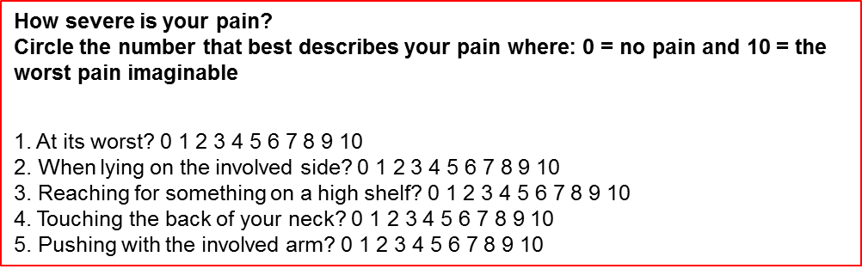
The following algorithm will then help to make a quick clinical decision as to when a patient is either in need of referral to a physiotherapy department or at risk of developing pain and disability (figure below):
Figure 14: Quick access Early Warning System to detect upper limb deterioration: Only Pain items on SPADI
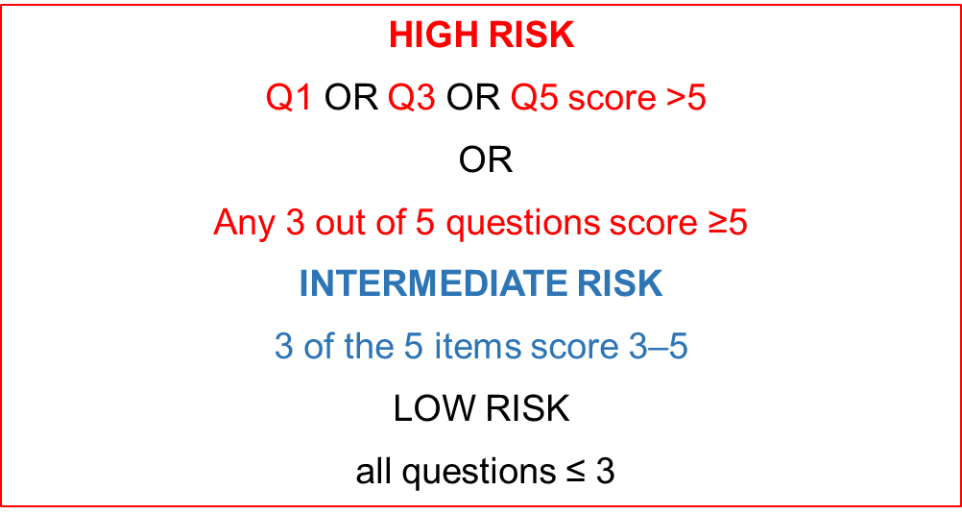
If a patient scores as high risk they should see a physiotherapist as soon as possible.
When patient scores as an Intermediate risk they must be advised that they are at risk of developing shoulder problems. They must make sure they are doing the exercises provided either on a pamphlet or by a physiotherapist. They must be given a number to contact if their movement becomes more painful and/or limited.
Low risk patients are given encouragement to continue with their exercise regime’.
The risk category can be used in conjunction with a test of the patient’s ability to move into forward flexion, abduction, horizontal flexion, internal and external rotation. The clinician must watch carefully for poor scapular movement such as shoulder elevation to assist in elevating the arm (a shrugging movement, Figure 3).

Figure 15: Examples of incorrect elevation of the scapula at rest and during arm abduction
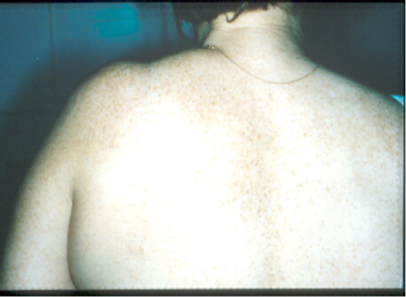

Upper Limb Rehabilitation:
There is substantial evidence supporting the effectiveness of different types of physical therapy in reducing upper limb pain and lymphedema, and improving shoulder range of motion (and thus shoulder function) in breast cancer survivors presenting with upper limb morbidity. Previous findings suggest that shoulder morbidity after breast cancer treatment is bilateral and it has been shown that structures unrelated to direct surgery and/or radiotherapy treatment are affected hence the need to include both arms. The most important message for providing exercises for the upper limb is to ensure that scapula stabilisation and timing, with glenohumeral movement in both arms, is included.

Exercise Guideline Recommendations:
- Post-operative physical therapy should begin the first day following surgery. Gentle range of motion exercises should be encouraged in the first week. This can include:
- Active pain free range of flexion, abduction, extension, Scapula depression, elevation, circumduction, Isometric muscle contraction across the scapula and glenohumeral joints.
- Active, gentle stretching can begin week 1 after surgery, or when drain is removed. Pay attention to axillary and neck stretches. Keep doing for 6-8 weeks or when shoulder movement is restored.
- Encourage scar and surrounding tissue massage.
- Progressive resistive exercises (strengthening) for the muscles of the arm and the scapula can begin with light weights (0.5kg – 1 kg) within 4-6 weeks after surgery.
It is important to remember that every patient will progress at their own pace but some may need more encouragement. Educating the patient on the value and low risk associated with exercises will encourage adherence. Patients must be taught to recognise symptoms of early upper limb complications (ie. pain associated with any of the questions listed in figure 1) so that they can seek assistance at an early stage.

Key Area 7: Data, monitoring and research

Standard 7.1: Reliable monthly and annual figures should be available from each facility providing breast examination or care, in particular each PHC, RBU, SBU and POU.

Standard 7.2: It is recommended that SBU and POU have database information on patients for clinical management, further surveillance and research purposes.

Standard 7.3: Population based breast cancer incidence and mortality should be available using a national cancer registry
Standard 7.1, Standard 7.2, and Standard 7.3 are addressed together below.

Monitoring and evaluation is a central component of a cancer control strategy and is critical to the ongoing success and utility of a cancer control plan. It refers to the ongoing effort to achieve measurable improvements in efficiency, effectiveness, performance, accountability and outcomes to improve population health in an equitable manner.

A comprehensive cancer control strategy is a complex and dynamic program with some indicators being relatively intangible and difficult to measure. Furthermore, outcome and impact results of cancer strategy are expected to take many years to become evident and measurable. Therefore, a long-term perspective, particularly for cancer health outcomes, is critical. For a country in the first years of implementing a comprehensive cancer policy, equally important are the input and process measures that allow for the immediate measurement of progress and identification (and resolution) of problems encountered during implementation of priority interventions.

A comprehensive monitoring and evaluation plan for the current breast cancer strategy includes harnessing existing, relevant sources of health data together with planning the infrastructure for new critical health information to be added. A strategic position would be to concentrate on a few, carefully considered input, process and outcome measures that together cover a large number of progress areas through routinely collected administrative and surveillance data.

The overall, long term goal of this policy is to achieve a significant, measurable reduction in breast cancer incidence, morbidity and mortality. Sustainable and mature cancer surveillance systems are the critical component to effectively tracking these outcomes/impact changes. While the South African pathology-based cancer registry is adequate to describe the general pattern of cancers in the country, population-based cancer registration is the global gold standard for cancer surveillance. Investment in population-based cancer registration would provide the opportunity to describe overall breast cancer incidence, survival outcomes, and certain demographic and clinical characteristics of the breast cancer patients presenting for care. Sentinel surveillance sites across the country will be established with support from public and private health care practitioners. The inclusion of routinely collected mortality data from vital statistics (Department of Home Affairs and Statistics-South Africa) would complement breast cancer surveillance and complete the description of South African breast cancer burden.

Research priorities for breast cancer in South Africa cover the spectrum of research areas from basic sciences, to clinical, public health, health economics and operational research. Clinician collected data is an important component of the monitoring and evaluation of breast cancer strategies. Patient case series at specialized breast units lend themselves to in-depth data collection on individual patients, tailored to the context of the unique health facility. Patient characteristics such as stage at presentation, risk factors and clinical decisions can be recorded. This record could serve as the electronic medical record of the patient facilitating multi-disciplinary team discussion, clinical management, and reliable follow-up of patients. Patient case series lay the foundation for survival and outcomes research, a research area sorely lacking in the South African context.

Although routine health information systems are regularly used for facility and district level planning, they may be overlooked when evaluating health programs due to concerns over quality and completeness of data. With 132 monthly performance indicators already included in the National Indicator Dataset for 2017-2019, the facility performance measures for breast cancer must be carefully selected so as to ensure continuous and high-quality reporting for breast cancer. Consultation on a standardized set of indicators with stakeholder agreement of definitions and methods of data collection are required.

A detailed monitoring and evaluation plan outlining indicator definitions, sources of data, reporting intervals, flow of data and resources for M&E will be developed in consultation with health services.

Key area 8: Community outreach and engagement

Standard 8.1: User-friendly educational materials available in all PHC/DH areas

Summary of critically evaluating the educational material
The objective of breast awareness in communities is to ensure that women and men at community level are informed about the following aspects:
- General awareness around healthy lifestyle choices, knowing your risks, knowing what is normal for you, get screened,
- What the breast look like
- Breast cancer risk factors
- Breast cancer warning signs and symptoms
- Breast self-examination

It is important that presenters of breast cancer awareness and education messaging in communities only focus on these five areas. In support of the breast cancer guidelines it is therefore important that the end result is that if any symptoms are detected by a person, she/he needs to ensure that they attend the local CHC for a clinical breast examination by an appropriately trained health care professional (Registered nurse or medical doctor). Patients with symptoms will be triaged to the relevant RBU or SBU for screening and diagnosis. Therefor any additional information that is related to post diagnosis of breast cancer such as treatment modalities and survivorship should not form part of any presentation as it will only lead to confusion and scare. Stigmatisations of cancer play a vital role in awareness campaigns communication materials therefor have to be
- Neutral in terms of gender and race
- user friendly,
- non-ambiguous,
- language appropriate
- evidence based

All written material such as posters and pamphlets should be developed to support uniform and standardised messaging. Presentation content should be sourced from reputable sources Visual presentations should be focussed, short concepts and extreme examples should be avoided at all times.
Presentation of awareness and education messaging in communities should ideally not be longer than be longer than 30 minutes. Ideally women should be educated in small groups of not more than 10 per group on Breast Self-examination as a self-screening tool. Many cancer civil society organisations are available to conduct awareness and education in urban communities.

Cancer Civil Society directly involved in breast cancer awareness and education are:
Cancer Alliance with the Advocates for Breast Cancer www.canceralliance.co.za
Pink Drive www.pinkdrive.co.za

Standard 8.2: Teaching programmes developed and made available for healthcare workers at all levels.
Individualised teaching programmes should focus on the following levels of health care workers:
Level 1: Laymen which would include community health care workers, civil society volunteers and educators and patient navigators. The training will focus on general breast health awareness.
Level 2: For entry level health professionals including nurses the training will focus on clinical breast examinations, triage and referral pathways.
Level 3: Medical practitioners from general to specialist training will focus on clinical breast examination, triage, diagnostic procedures and technique guidelines and referral pathways
Level 4: Specialised health care professionals such as physiotherapists, pharmacists, oncology social workers, palliative care specialist, lymphedema specialists training will focus on management of breast cancer patients post diagnosis.

Level 1 training can be conducted by members of the Advocates for Breast Cancer civil society organisations. These organisations can be contacted via the Cancer Alliance website www.canceralliance.co.za

A train-the-trainer programme will be implemented for community health workers and health promoters to support the breast policy by the National Department of Health in collaboration with civil society.

Training for Level 2, 3 and 4 health care workers will be available online with effect of 1 June 2018. The Breast Cancer Education Platform is a web based platform designed to enable access to free education for Health Care Professional (HCP) in South Africa.

The platform will allow HCPs to access educational and informative content which is relevant to their role and enable them to self-educate and gain certified training on various aspects of breast health and breast cancer.

The content contained on this platform will be Continuous Professional Development (CPD) accredited and is aligned to the Breast Policy.

Annexures

Annexure to Standard 1.1: Provider Initiated Screening Clinical Breast Exams or “PISCBE” guideline
The following is a diagram on the appropriate technique for a clinical breast examination. It is Adapted from Breast Care (Bettercare series), Dr Jenny Edge, Prof Dave Woods.

EXAMINATION OF THE BREASTS

It is very important to be able to have a good look at both breasts.

1. Sit the patient down on the examining couch and look at her breasts with her arms relaxed. Look for breast asymmetry, nipple inversion, skin changes and redness.

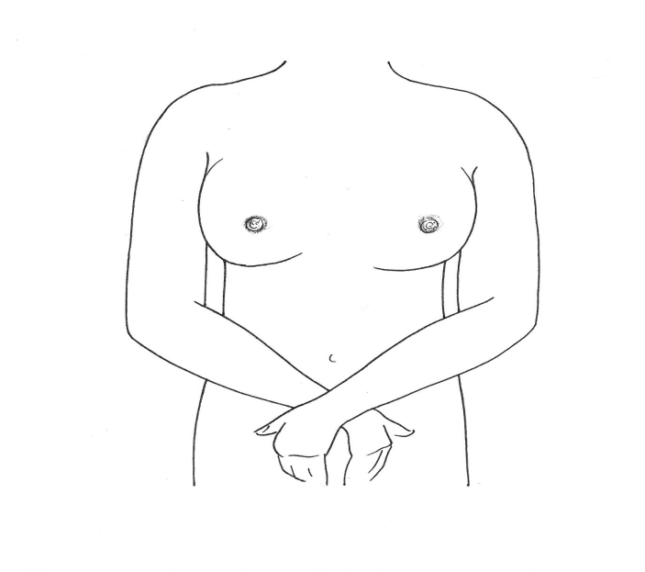

2. Ask the patient to raise her arms above the head. Look for any skin puckering. Ask the patient to point out where the problem is. Look specifically in that area to see if there is any change in the skin while she is moving her arm. This will help identify if a lump is attached to the skin.

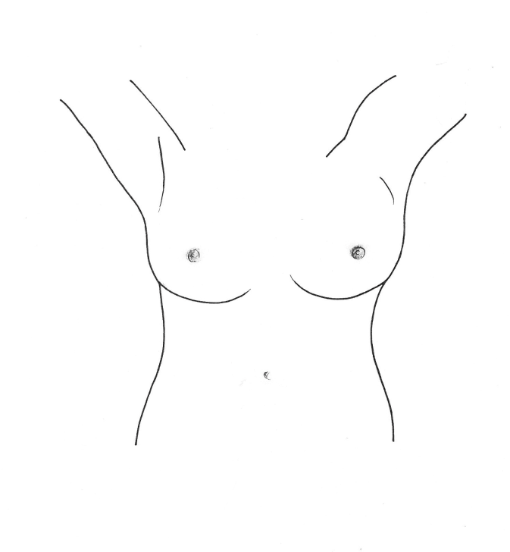

3. Ask the patient to put her hands on her hips and squeeze. Look and see if the area over the lump changes. This will show whether a lump is attached (tethered) to underlying muscle.

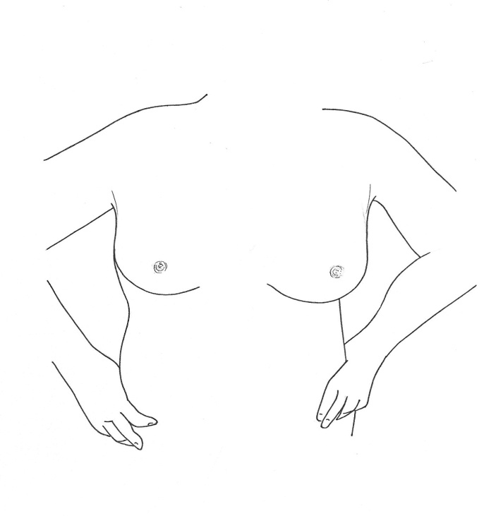
4. Feel in the area above the clavicle (collar bone) for any lumps in the neck.

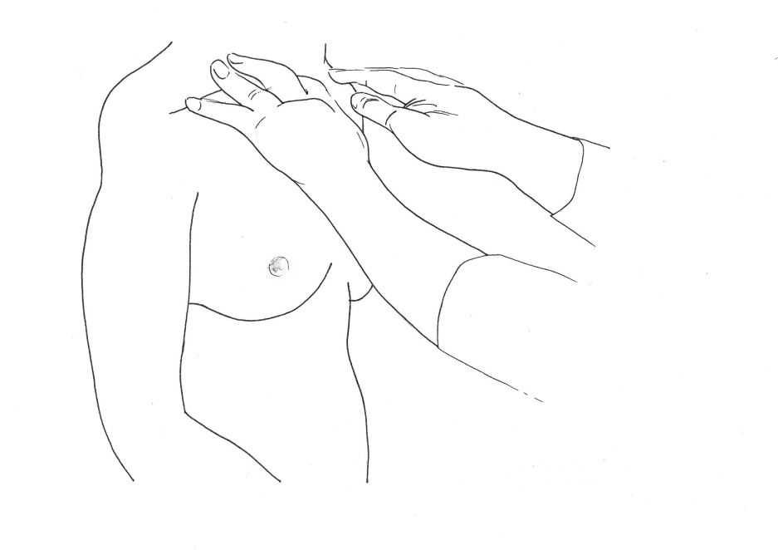
5. To examine the armpits properly the patient must be relaxed. If the patient is very ticklish it helps to press more firmly. The best way to get the patient to relax her muscles is by asking her to extend her arms and rest them on your shoulders while you examine the armpits.

Feel in the two armpits (axillae) at the same time for any lumps. This allows comparison of either side.

If you think you can feel a lump in one armpit it is best to examine that side alone. Palpating the armpits is an essential part of breast examination.

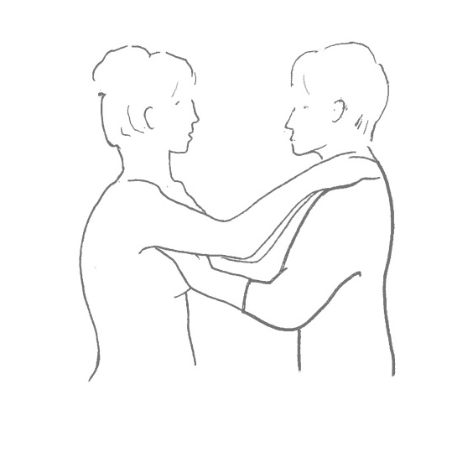
6. Finally lie the patient down flat on her back and palpate her breasts with her arms above her head. This will flatten the breasts and make examination easier. The breasts can be examined in strips, quadrants or in a circular manner. The impostnat thing is that the breast extends from the clavicle (collarbone) above to the 6th rib below. The whole area of the breast must be examined.

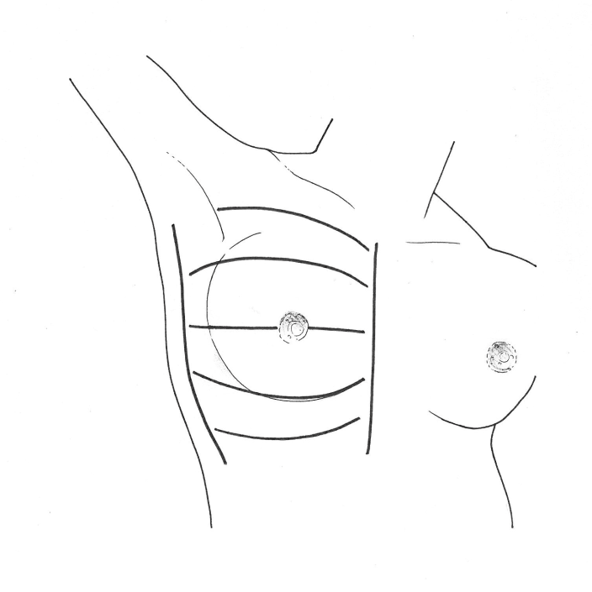
Always use the pulps of your fingers (the most sensitive part of your hand) with the rest of your hand gently resting against the breast. Do not use cold hands.
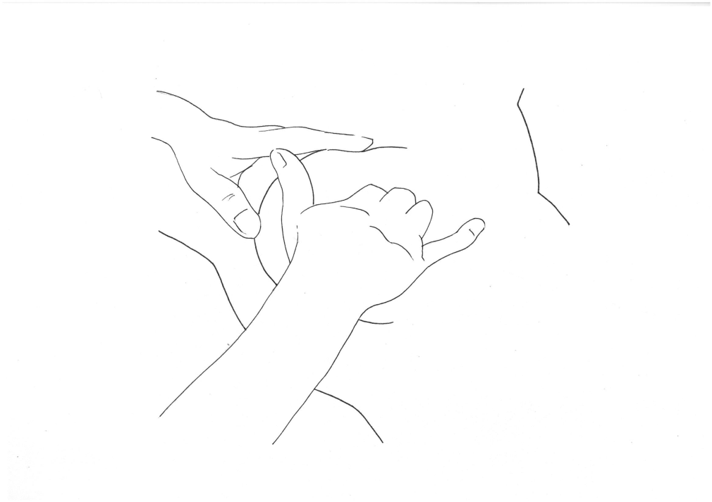

7. Examine behind the nipple areola complex (NAC) for any abnormalities such as skin changes, lumps or an inverted nipple. It is best to leave the nipple examination to the end once you have won the woman’s trust.

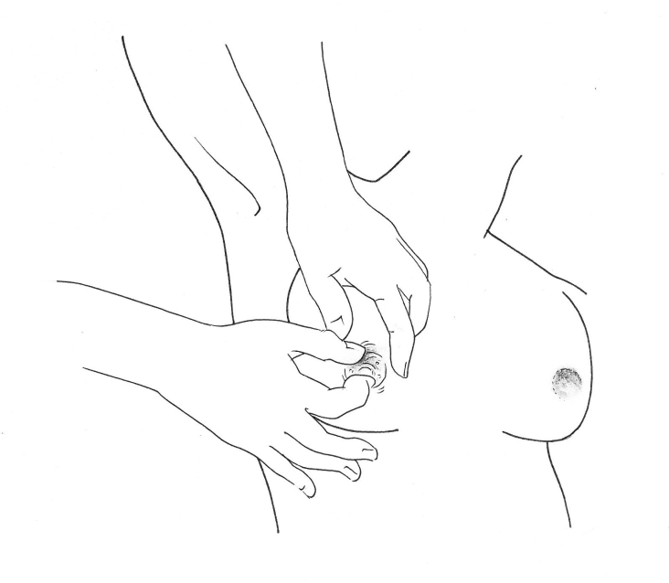

What to look for when examining the breast: asymmetry, skin changes, peau d’orange, redness, change in the nipple, inversion, change in the skin over the nipple or obvious discharge.

If a lump is found in the breast, the following should be noted: the texture, whether it is fixed to the skin or underlying muscle, the size, the mobility and if the lump has well defined edges.

Annexure to Standard 1.2: Example of printed educational material in facilities
Figure 16: Examples of an appropriate self-breast examination. Source: Groote Schuur Hospital
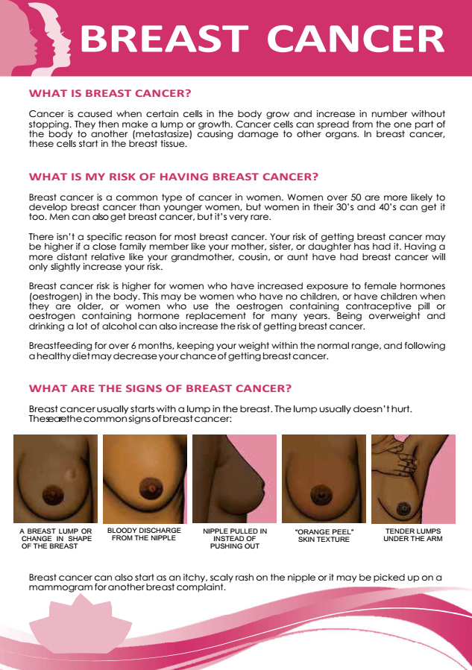

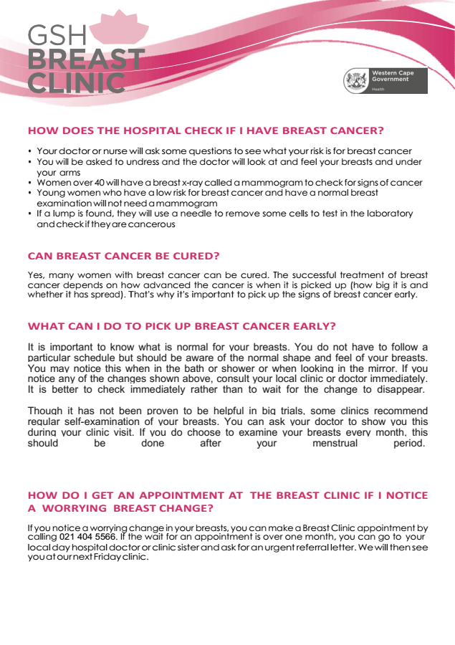

Annexure to Standard 1.3: Awareness messages
Figure 17: Example of awareness message on signs and symptoms of breast cancer. Source: National Department of Health South Africa
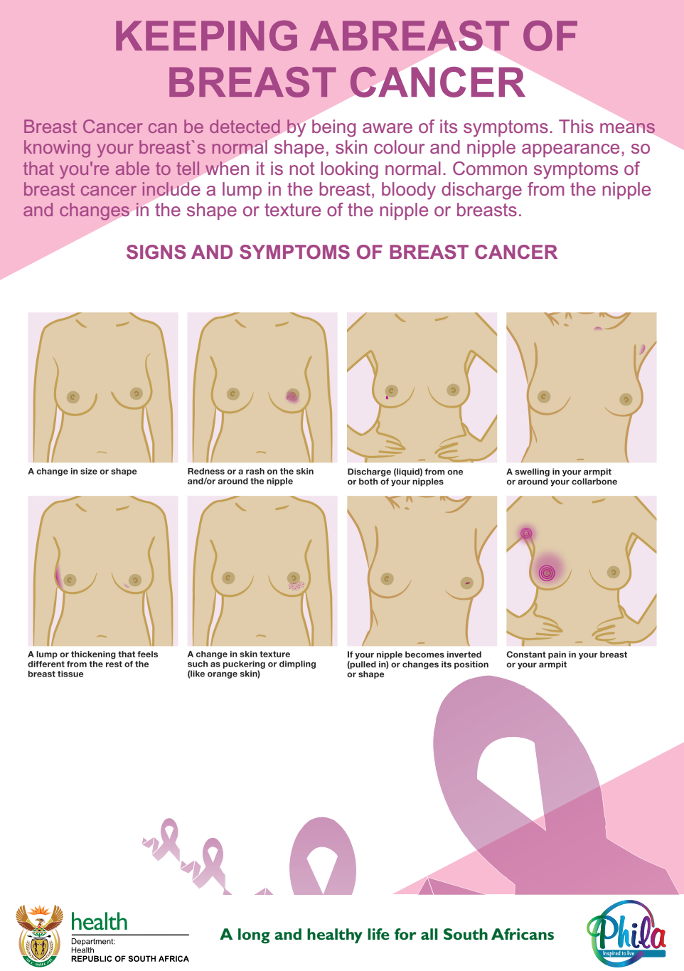
Figure 18: Example of awareness message for monthly self-examinations. Source: National Department of Health South Africa
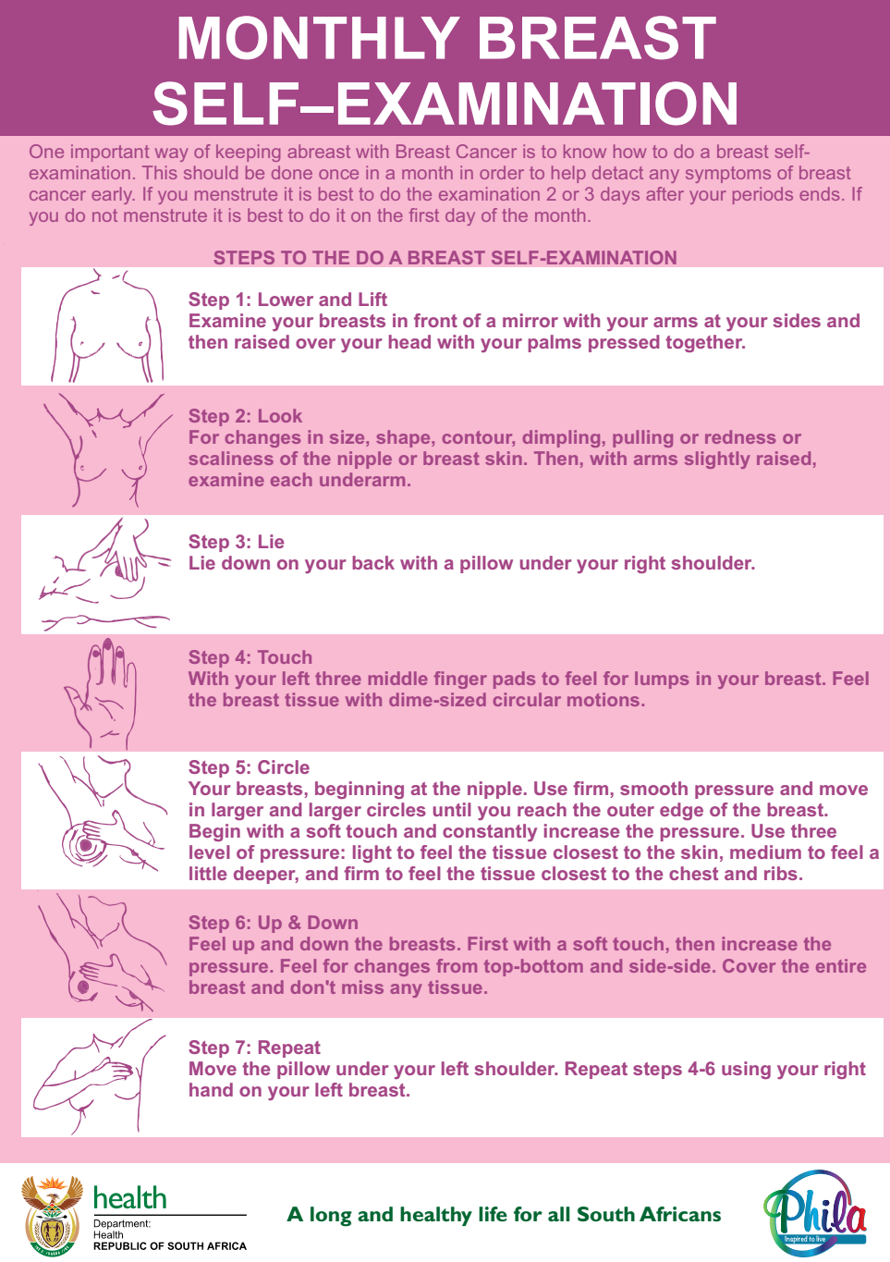
Figure 19: Example of awareness message for self-breast examination. Source: National Department of Health South Africa
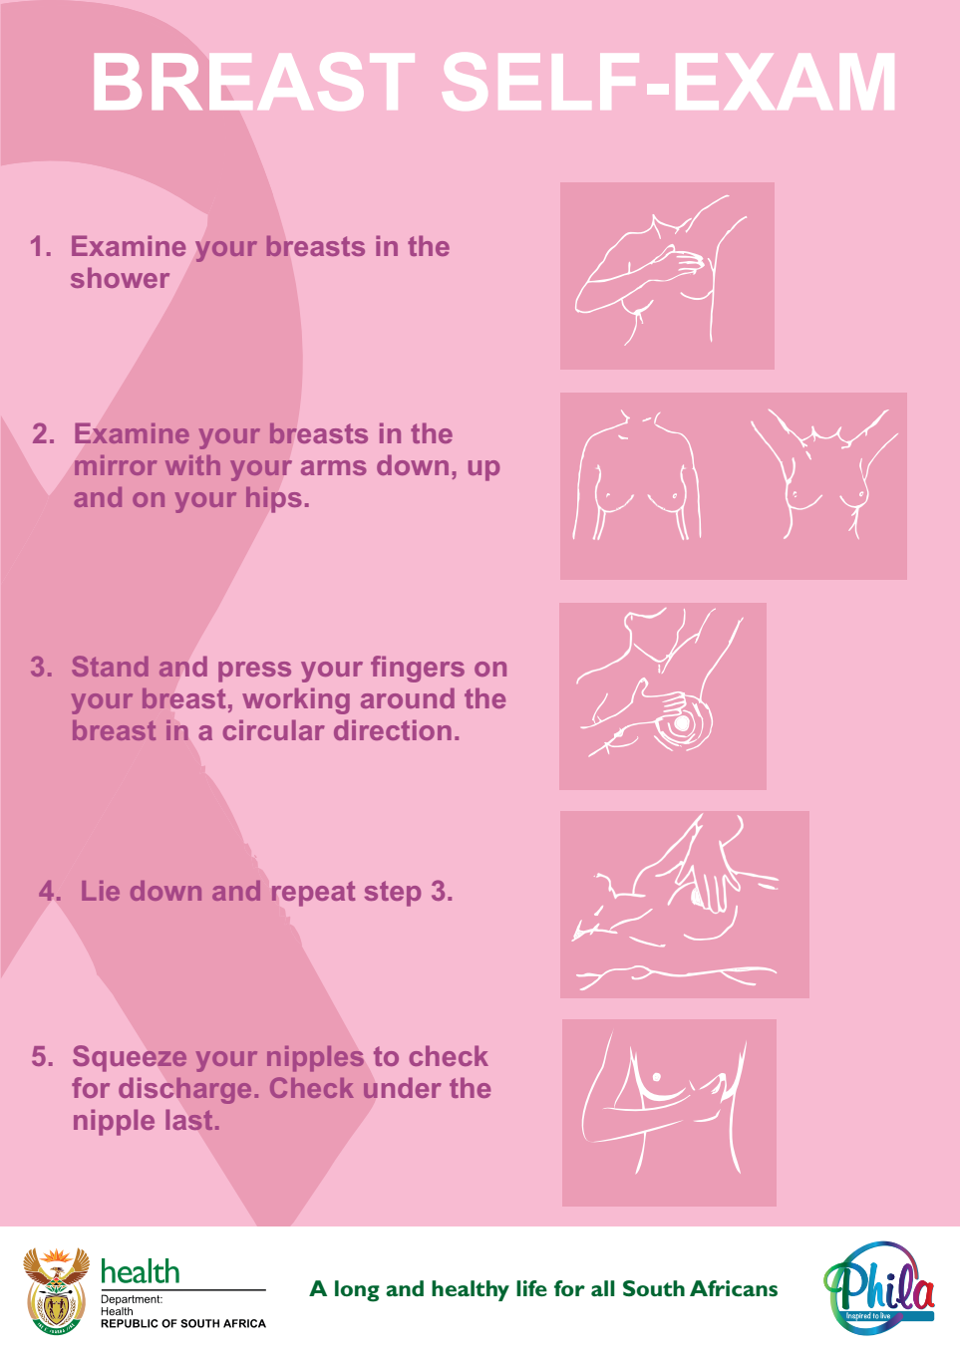
Figure 20: Example of awareness message for monthly self-breast examination. Source: National Department of Health South Africa
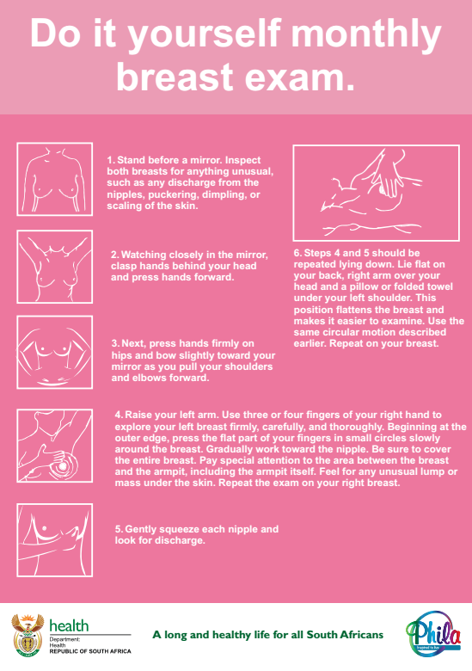

Figure 21: Example of a Z-fold information pamphlet created for the Breast Cancer Prevention and Control Policy (2017). Front.
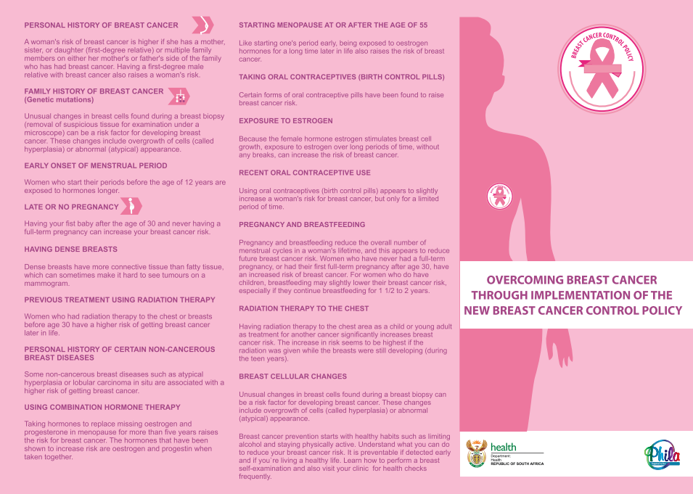
Figure 22: Example of a Z-fold information pamphlet created for the Breast Cancer Prevention and Control Policy (2017). Back.


Annexure to Standard 1.4: Risk of breast cancer assessment
Figure 23: Printable copy of the High-5 method. Source: National Department of Health South Africa

5
4
3
2
1
1. | Do you do self-breast exam regularly?  Yes or No
2. | Have you noticed any changes to your breast?  Yes or No
3. | Have you experience abnormal vaginal bleeding?  Yes or No
4. | Have you ever had a pap smear?  Yes or No
5. | Family history of cancer?  Yes or No

If YES is answered to any of the above questions, then follow-up with the following:
- When was your last breast exam? Pay particular attention to patients whose last exam was conducted beyond 6 months. If so, conduct clinical breast exam.
- Changes to your breast, such as a lump in breast or armpit? Use this as an educational opportunity. Look for the following items (check box):
  - Lump
  - Nipple discharge
  - Changes in colour
  - Skin changes
  - Pain
  - Any change in the size of the breast and/or swelling
- Do you experience any abnormal vaginal bleeding? Ask for bleeding after (check box):
  - After sexual intercourse
  - Post-menopause
  - In-between menstrual cycle
- Have you ever had a pap smear? When was your last pap smear? Were there any abnormalities communicated to you?
- Do you have a family history of cancer? Use this as an opportunity to explore further.

Annexure to Standard 1.7: Risk calculator
The following are examples of risk calculators for breast cancer that were recommended by specialists who practice in South Africa in the public sector; there are a number of risk calculators available online that you can use. The National Department of Health does not promote use of any specific risk calculator and accepts no responsibility for clinical decision arising from their use.

- The Breast and Ovarian Analysis of Disease Incidence and Carrier Estimation Algorithm (BOADICEA) calculates the risk of breast and ovarian cancer based on the family history. It can also be used to calculate the probability that an individual is a BRCA gene carrier. http://ccge.medschl.cam.ac.uk/boadicea
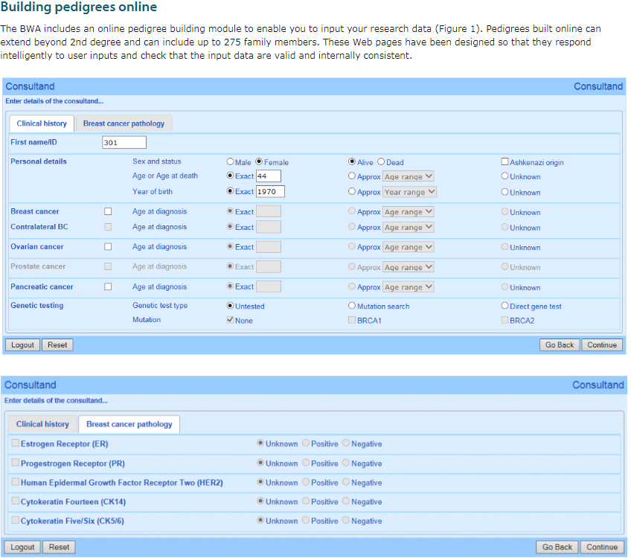
- International Breast Cancer Intervention Study (IBIS) is a risk assessment tool developed by scientists at the Wolfson Institute of Preventive Medicine, Queen Mary University of London and is provided for non-commercial research purposes only. http://www.ems-trials.org/riskevaluator/
Figure 24: Example of risk breast cancer calculator. Source: IBIS Breast Cancer Risk Evaluation Tool
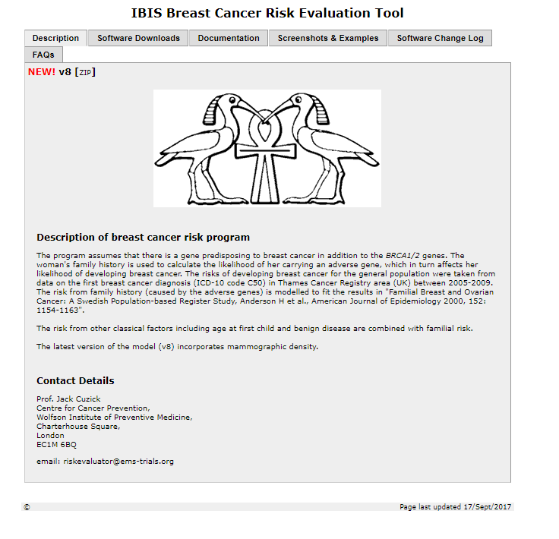

Annexure to Standard 2.1: RBUs should meet the minimum standards to provide accurate diagnosis of breast conditions.

Qualifications for a breast nurse

Breast training for health care workers: module 1
A short course (one semester) will be run by University Stellenbosch (US) department Nursing and Midwifery. The course will be suitable for health care workers working in a breast clinic and will result in a certificate of competency from US. The first course will start in July 2018

Aim of course: To enable a health care worker to evaluate a patient with a breast problem and categorise the patient as having a malignancy, indeterminate lesion or benign lesion. All patients with breast cancer should be reviewed by the multidisciplinary team. All patients with an indeterminate or benign lesion should be assessed by a medical officer prior to discharge from the clinic.

Type of course: The course will be a short course and run over one semester. It will be a combination of a residential lecture block (one week at US) and supervised online project based assessments.

The course content will consist of:
- Detailed clinical assessment of a person with a breast problem (history and examination)
- Normal development of the breast
- Breast anatomy
- Radiological investigations of the breast: indications and limitations
- Indications for genetic referral
- Pathological investigations of the breast (cytology and histology): indications and limitations
- Interpretation of results of investigations
- Screening investigations: which patients should be referred and when.
- Basic understanding of treatment of breast cancer and the side effects.

Breast training for health care workers: module 2 and 3
Aim:
- To assist patients and their family through breast cancer management.
- To provide holistic and comprehensive management of patients with breast cancer.
- To provide follow up for a breast cancer survivor.
- To identify and understand palliative care provision

Type of course: The course will be a short course and run over 6 months. It will be a combination of a residential lecture block (one week at US) and supervised online project based assessments.

The course content will consist of
- Breast cancer management
  - Principles of breast cancer treatment – how, why, what.
    - Surgery, Chemotherapy, Radiotherapy, Endocrine therapy, Targeted therapy
  - Lymphedema management
  - Comprehensive and holistic care of the patient.
    - Physical, Emotional, Social , Economic, Spiritual
  - Patient advocacy
  - Management of special cases: pregnancy, HIV, males with be cancer
- Breast cancer navigator training
  - Navigation through treatmen
  - Patient / family support
  - Patient / family education
  - Support / volunteer programmes
- Follow up of breast cancer survivors
  - Understand cancer follow up (based on biology of cancer) and issues of the cancer survivor:
    - Fertility/contraception
    - Screening for new cancers: when and how
    - Assessing for metastatic spread
    - Endocrine therapy
    - Complications of cancer treatment

Annexure to Standard 2.1: Example of communication package for patient at each consultation
The following is a copy of patient journey information leaflet adapted from Mitchells Plain Hospital.

Welcome to the Breast Clinic (RBU):

We aim to provide accessible, high quality service for the diagnosis and management of breast diseases.

The Breast Team consists of breast consultants (specialists) and doctors, a radiologist, radiographers, oncology specialist and the nursing staff. We all work together to ensure that you have an excellent patient experience.

Possible Diagnostic Tests

1. Mammogram
This is a low-dose X-ray of your breast. This is the most common test requested by the doctor to view your breasts. If it is not possible to have the mammogram on the same day, one will be booked for you. You must try not to miss your appointment.

Please note that many breast conditions DO NOT NEED A MAMMOGRAM. The doctor will request a mammogram according to the clinical guidelines and criteria set out by the Head of Breast Surgery.

2. Ultrasound
This is another way to obtain an image of the breast. If needed, an appointment will be made for you at Groote Schuur Hospital. Please try to keep this appointment.

3. The Needle Tests and Biopsy
If needed, two different needle tests will be done. A FNA (fine needle aspiration) and or core biopsy, punch biopsy and Tru-cut biopsy.

The needle test

- The doctors will use two different needles to do the needle test.
- The one needle takes a sample of the breast cells using a syringe, and the other needle takes a piece of breast tissue.
- This may be an uncomfortable experience, but rest assure, the doctor will use some local anaesthetic before doing the needle tests.
- The breast cells will be looked at under the microscope by the pathologists in the clinic. PLEASE be patient, the doctor will discuss the provisional results with you before you leave!
- The second needle with the breast tissue will be sent to the laboratory and the results will be available in 5 days.

Taking care of your breast after the needle test

Keep the dressing on your breast for at least 24-48 hours and note for any active bleeding.
Some good advice!! SLEEP with your bra on. This will help with excessive movement of your breasts. NO aerobics for 72 hours.
You can take the dressing off the next day. Keep the area clean and dry.
If you have any pain, take two mild pain killers example Paracetemol (Panado).
Your breast may develop bluish, reddish or yellowish colour around the area the needle test was done. DON’T be alarmed. This is to be expected as it heals.
You can place a cold cloth on your breast and keep it on for 10 minutes. Alternate this with a warm cloth on your breast. The heat will also help to relieve the pain and discomfort you may experience.
Repeat this action for at least one full day i.e. 24 hours.
If you notice any signs of inflammation such as swelling, redness or fever, DO NOT hesitate to call us.

PATIENT INFORMATION
REFERRAL TO SBU

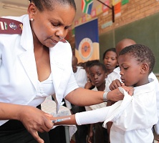
You will see the Nurse who will take your personal information.


The Doctor, who is a Breast Specialist, will give you the results of the needle test. You may have to go for further tests e.g. Chest X-Ray, Bone scan or a Mammogram. The nurse will give you these dates. Please keep these appointments.


You may have to see the social worker who is part of the Breast Team.

A date will be given to you to come back. This is where a panel of doctors will give you the final results and discuss the way forward.
Please feel free to bring somebody with you to listen to what the doctors has to say.
You or your family member can make a list of questions you may want to ask and bring it along with you.

THE PANEL DISCUSSION

The panel consists of a multidisciplinary team of specialists from the Departments of Surgery, Radiology, Oncology, Pathology, and Plastic Surgery. Included in the team is the Breast Nurse, nursing staff and the Social Worker.
The team will discuss all your results and provide you with a treatment plan that is specifically for you. If you have any questions, queries or uncertainties please discuss it with the team.
If you need more time to think about the planned treatment before you make a decision, please inform the Breast Team.
You do not have to make an immediate decision.

SOME QUESTIONS YOU MAY WANT TO ASK:

General questions:

- Why do I need more tests and what do you expect them to show?
- When will the results be available?
- Can I get a second opinion?
Support:
- Can I talk to a counsellor?
- Is there a counsellor available to talk to my family?
- What should I tell my family?
- What should I tell my children?

Information:
- Where can I get more information?
- Who can I contact if I have more questions between now and when I see the panel?

PLEASE MAKE EVER EFFORT TO ATTEND

Call the receptionist at the clinic on the day of the appointment to give you clear directions to the clinic at.

Patient Information- Ultrasound biopsy
Where will it be done?
This procedure is done at [Insert name of facility and room housing the radiology unit]
What to wear
Clothes that is easy to take off e.g. shirt and blouse or shift dress. Wear or bring a supportive bra.
What not to wear during the procedure:
- Jewellery
- Eye glasses
- Metal objects
- Clothing that will interfere with the x-ray images
- Perfume, body cream, lotion or deodorant
Report the following to the doctor before the procedure:
- What medication you are using e.g. Aspirin and other blood thinning medicines or Herbal medication. If you are using blood thinning tablets, it is advised to STOP taking it two to three days before the test to prevent excessive bleeding after the procedure
- Any recent illnesses or medical conditions.
- Any allergies
How to prepare for an ultra sound biopsy
There are no diet restrictions, you can eat and drink as usual and take your daily medication on the day of your appointment.
What to expect during the procedure
- During an ultrasound-guided biopsy, you will lie on your back on a padded table with one arm raised above your head. You will be able to watch the ultrasound screen as the radiologist performs the procedure if you wish.
- Your skin will be cleaned before the radiologist gives a local anaesthetic.
- You will feel a slight pin prick from the needle and some pressure when the biopsy needle is inserted. The area will become numb in a short while.
- You must be still while the procedure is done
- This will numb an area about the size of a quarter. A very small nick will be made in the skin and several tissue samples will be obtained.
- During the procedure you will be informed about what is occurring. If you experience discomfort, the radiologist can administer more local anaesthetic during the procedure.

How is the procedure performed?
- Sound waves are used while doing the ultrasound. When the waves strike a mass in the breast, it bounces back and an image is formed.
- The Radiologist will be able to determine the size, shape, appearance and contours of tissues, vessels or abnormal masses or tumours. It shows whether a mass is solid or filled with fluid.
- Using an ultrasound probe to see exactly where the breast mass is, the radiologist inserts a biopsy needle through the skin and advances it to where the mass is and removes tissue samples.
- Sometimes during an ultrasound, a guide wire may be used to guide the Radiologist directly to where the mass is.
- No stiches are needed. This procedure is usually completed within an hour.
After the procedure
The Radiologist or mammographer will apply pressure to the area where the biopsy was taken from to stop any bleeding. A bandage will be placed over the cut in the skin.
Taking care of your breast after the needle test
- Keep the dressing on your breast for at least 24-48 hours and note for any active bleeding.
- You can place a cold cloth on your breast and keep it on for 10 minutes. Alternate this with a warm cloth on your breast. The heat will also help to relieve the pain and discomfort you may experience.
- Some good advice, SLEEP with your bra on. This will help with excessive movement of your breasts. NO aerobics for 72 hours.
- You can take the dressing off the next day. Keep the area clean and dry.
- If you have any pain, take two mild killers example Panado.
- Your breast may develop bluish, reddish or yellowish colour around the area the needle test was done. DON’T be alarmed. This is to be expected as it heals.
- Repeat this action for at least one full day i.e. 24 hours.
- If you notice any signs of inflammation such as swelling, redness or fever, DO NOT hesitate to call us.
- Avoid heavy lifting for two days to prevent further bleeding or extended bruising.
- Avoid taking Aspirin for about 48 hours, the bleeding may take longer to stop.
- You should be able to drive home or return to work after the procedure or sometimes, it is just good to have a friend at your side.
How do I get the results?
- The specimen is sent to our laboratory at Groote Schuur Hospital, where it will be tested.
- A trained pathologist will look at the tissue samples taken and make a final diagnosis.
- Follow-up exanimations may be necessary so that the mass can be monitored. The doctor will explain to you why and if it is needed.
- You will be contacted by either the mammographer at C16 or Sister Fish when to return to the breast clinic for further follow-up.
What are the benefits vs. risks?
Benefits
- The procedure is less invasive and leaves little or no scaring and is done in about an hour.
- An Ultrasound uses no radiation
- An Ultrasound-guided biopsy provides tissue samples that can show whether a breast lump is benign or malignant
- With an ultrasound, it is possible to follow the movement of the needle as it moves through the breast tissue.
- An Ultrasound-guided biopsy is able to evaluate lumps under the arm or near the chest wall, which are sometimes hard to reach.
- Recovery time is short and you can resume your usual activities sooner.
Risks
- There is an overall risk of less than1% of bleeding, clot formation or a collection of blood at the biopsy site.
- Some patients may experience discomfort, which were controlled by mild pain killers, i.e. Panado.
- Any procedure where the skin was penetrated has the risk of infection.
What are the limitations of an Ultrasound-guided biopsy?
- It sometimes happens that a breast mass is missed. If the results still show to be uncertain after a successful procedure, it may require the entire mass to be taken out during another procedure.
- Some very small breast lesions may be very difficult to target during this type of procedure.

Mitchells Plain Hospital
Patient Information Breast Ultrasound
The aim of this information sheet is to help answer some of the questions you may have about having an ultrasound scan of the breast. It explains the benefits and risks of the procedure as well as what you can expect when you come to hospital. If you have any questions or concerns, please do not hesitate to speak to a radiographer in the Breast Imaging Unit or with one of the nurses. Contact numbers are included at the bottom of this sheet.
What is breast ultrasound?
An ultrasound provides images of organs and soft tissues inside your body. It uses sound waves to make images. It does not use radiation. This test does not hurt.
Why do I need a breast ultrasound?
A breast ultrasound helps the radiologist learn more about what a breast lump is made up of. It will show whether a lump is a fluid-filled cyst or a solid mass.
What are the benefits – why should I have this procedure?
Ultrasound scans are able to detect changes within your breast, some of which you may be aware of (such as a breast lump). An ultrasound scan may also detect changes that cannot be felt during a physical examination. This includes lesions located deep within your breast which may require further investigation.
Ultrasound scans are performed by radiologists that are specially trained to perform and interpret scans.
What are the risks?
There are no known risks. Ultrasound does not involve using x-rays and is considered to be very safe.
Are there any alternatives to an ultrasound?
There are no alternative methods of imaging the breast in a similar way to a breast ultrasound. An alternative you may be offered is a clinical examination and a biopsy by a breast clinician.
How can I prepare for an ultrasound scan?
- There are no special preparations beforehand for this procedure. You can eat and drink normally before and after.
- On the day of your appointment, we advise that you wear clothes that can be easily removed, as you will be asked to undress from the waist upwards.
- Please do not wear deodorant, powder, lotion or perfume on your breasts and under arm areas as ultrasound gel will be applied to your breast and under arm area during the examination. Some deodorants, lotions, powders and perfumes can affect the accuracy of breast examination.
- Try to bring a friend or relative to accompany you home. This may also be useful if you do not understand English very well or if you have any special needs. Although your friend or relative may not be allowed into the examination room, they can be a valuable source of support for you on the day. If you require an interpreter to attend your appointment, please let us know.
- You should also note that we are unable to offer childcare facilities. If you need to bring your children with you, please bring along an adult who can supervise them when your examination is being carried out.
Giving my consent (permission)
- The staff caring for you may need to ask your permission to perform a particular treatment or investigation. If there is anything you do not understand or you need more time to think about it, please tell the staff caring for you.
- Remember, it is your decision and you can change your mind at any time. Please let staff know if you change your mind. Your wishes will be respected at all times. If you would like to find out more about the procedure, ask staff caring for you.
What happens during the procedure?
- The procedure should last no longer than 30 minutes, however please allow extra time in case of delays on the day or your appointment.
- The radiologist will first discuss your breast problems with you.
- You will be asked to remove all of your clothes from the waist up and to lie on the examination couch.
- Here, your breast may be examined to check the position of any lumps. A water-based clear gel will be applied to the skin of your breast.
- This allows the ultrasound probe to slide easily over the skin and helps to produce clear pictures.
- The radiologist will slowly move the probe over the skin when viewing the images produced on the monitor.
- The lights in the room will be dimmed so that the pictures on the screen can be seen more clearly, and records of selected images will be made so that they can be viewed later.
- Once the examination is over the gel will be wiped off and you will be free to get dressed.
Will I feel any pain?
If you suffer from general breast tenderness it is possible you may feel a mild degree of discomfort as the probe passes over the breast, but for the majority of women ultrasound is a painless examination.
What happens after the procedure?
The ultrasound images will be reviewed by the radiologist, and a report will be issued to the doctor that referred you.
What do I need to do after I go home?
You can go back to normal activity straight away, including work and sports.
What should I do if I have a problem?
Following an ultrasound scan you should not have any adverse after-effects to cause concern. However, we have included contact numbers at the bottom of this sheet if you feel you need any advice.

Will I have a follow-up appointment?
You must return to the clinic 1-2 week after the tests have been completed or otherwise advised. You will receive the results from your consultant at your next appointment. Please make sure that an appointment is arranged for you to come in and discuss the results and further management if needed.

Definition of a Breast Ultrasound
An ultrasound scan uses high frequency sound waves to produce pictures of the inside of the breast. It is used to evaluate breast abnormalities that are found with screening or diagnostic mammography or during a clinical breast exam.
Appropriate Indications for a Breast Ultrasound include, but not limited to:
- Women with high breast density, fibrocystic breast disease, young women with masses and pregnant women with masses

- Palpable masses and other breast related signs and/or symptoms
- Suspected or apparent abnormalities detected on other imaging studies, such as mammography.
- Evaluation of palpable masses in women under 30 years of age who are not at high risk for development of breast cancer, and in lactating and pregnant women.
- Evaluation of problems associated with breast implants.
- Evaluation of breasts with microcalcifications and/or architectural distortion suspicious for malignancy or highly suggestive of malignancy in a setting of dense fibroglandular tissue, for detecting an underlying mass that may be obscured on the mammogram.
- Ultrasound Guidance of breast biopsies and other interventional procedures.
- Treatment planning for radiation therapy
- As a supplement to mammography, screening for occult cancers in certain populations of women (such as those with dense fibroglandular breasts who are also at elevated risk of breast cancer or with newly suspected breast cancer) who are not candidates for MRI or have no easy access to MRI.
- Identification and biopsy guidance of abnormal axillary lymph node(s), for example in patients with newly diagnosed or recurrent breast cancer or with findings highly suggestive of malignancy or other significant etiology.
How to book a Breast Ultrasound at GSH Radiology
- Speak to the mammographer.
- Provide some clinical detail of the patient i.e. age and reason for Ultrasound.
- Provide name, folder number and contact details of the patient.
- Document the date, time and location on patient’s appointment card.
- Confirm correct contact details (mobile, home number and address),
Provide clear instructions to the patient about:
- Time of the appointment
- Location
- Who to report to
- Follow-up date with results (3 weeks after procedure or if otherwise indicated)
Definition of an Ultrasound Biopsy
In ultrasound-guided breast biopsy, ultrasound imaging is used to help guide the radiologist's instruments to the site of the abnormal growth.
An Ultrasound breast biopsy is performed to remove some cells either surgically or through a less invasive procedure involving a hollow needle from a suspicious area in the breast and examine them under a microscope to determine a diagnosis. Image-guided needle biopsy is not designed to remove the entire lesion, but most of a very small lesion may be removed in the process of biopsy.
Appropriate indications for an Ultrasound-Guided Biopsy, but not limited to the following:
1. Simple and complicated cysts when:
- They are symptomatic.
- It is unclear whether the lesion is a complicated cyst or a solid lesion.
- Imaging guidance would help avoid complications such as penetration of the pectoral muscle and improve accuracy.
- Correlation with other imaging findings (mammography, MRI) is likely to provide important diagnostic information that will guide patient management.
- Abscess or infection is suspected and diagnostic aspiration and/or therapeutic drainage is clinically indicated.
2. Complex cystic and solid masses when:
- Masses are assessed as highly suggestive of to confirm the diagnosis and guide definitive treatment.
- Masses are assessed as suspicious.
- There is more than 1 suspicious mass, particularly in a multicentric distribution, to facilitate treatment planning.
- Masses are assessed as probably benign only when there are valid clinical indications. Masses seen on directed-ultrasound examination correlate with suspicious areas of enhancement present on contrast-enhanced breast MRI.
3. Microcalcifications when:
- Microcalcifications seen on directed ultrasound examination correlate with suspicious calcifications visualized on mammography [7-9]. Specimen radiography should be performed in this setting to document sampling of calcifications.
4. Repeat biopsy
- Repeat ultrasound-guided percutaneous core or vacuum-assisted needle biopsy sampling is an alternative to surgical biopsy in cases when the initial core biopsy results are non-diagnostic or discordant with the imaging findings, additional tissue is necessary for tissue biomarker analysis, or if an initial FNA biopsy yields atypical, suspicious, or non-diagnostic cytology.
5. Pre-surgical localization
- Ultrasound-guided localization may be performed when the lesion or an appropriately positioned marking device placed during a previous biopsy is identifiable with ultrasound
6. Biopsy of lymph nodes in the axilla/axillary tail in cases of known or suspected malignancy.
- When the suspicion of malignancy is high, and if abnormal lymph nodes are seen within the axilla or axillary tail, FNA or core biopsy sampling of the cortex of the abnormal lymph node(s) can be performed at the time of initial imaging-guided core biopsy of the suspicious breast mass, or at a later time
How to book a Breast Ultrasound biopsy
- Call the mammographer
- Provide patient’s details, i.e. Name, Surname, Folder number, correct contact details (mobile, home number and address)
- Inform the patient she/he will be called with an appointment date.
Provide clear instructions to the patient about:
- Time of the appointment
- Location
- Who to report to
- Follow-up date with results (1-2 weeks after procedure)
All Information compiled by Sister Fish (Breast Health Coordinator) using the World Wide Web.
Reviewed by:
Dr N. Abdurahman (Senior Radiologist)
Mrs Y. Van Der Schyff (Chief Mammographer)
April 2015

Mitchells Plain Hospital

Stereotactic Breast Biopsy

What is Stereotactic Guided Breast Biopsy?

A stereotactic breast biopsy is when a special mammography machine uses x-rays to help guide the doctor’s instruments to the exact site of the growth in the breast.
Stereotactic breast biopsy is an excellent way to evaluate calcium deposits or tiny masses that are not visible on ultrasound.

Where will it be done?
This procedure is done at [Insert unit name and facility name].

What to wear
Clothes that is easy to take off e.g. shirt and blouse or shift dress.

What not to wear during the procedure:
- Jewellery
- Eye glasses
- Metal objects
- Clothing that will interfere with the x-ray images
- Perfume, body cream, lotion or deodorant

Report the following to the doctor before the procedure:
- Whether you are pregnant. The unborn baby may be affected by the radiation
- What medication you are using e.g. Aspirin and other blood thinning medicines or Herbal medication. If you are using blood thinning tablets, it is advised to STOP taking it two to three days before the test to prevent excessive bleeding after the procedure
- Any recent illnesses or medical conditions.
- Any allergies

It is recommended that you bring a friend or relative to accompany you and drive you home. You may be drowsy after the procedure!

How does the procedure work?
Stereotactic mammography pinpoints the exact location of a breast mass by using a computer and x-rays taken from two different angles. The radiologist inserts the needle through the skin, using the computer images as a guide, and removes some tissue samples.

How is the procedure performed?

Stereotactic breast biopsy is most often performed by a specially trained radiologist, usually on an outpatient basis. A specially designed chair is used for this type of procedure. You will be sitting in the chair while the doctor does the procedure.

Several x-ray images are taken.

A local anaesthetic will be injected into the breast to numb it.
A very small nick is made in the skin at the site where the biopsy needle is to be inserted.
The needle is inserted and advanced to where the abnormality is using the x-ray and computer generated coordinates.
X-ray images are again taken to confirm that the needle tip is actually within the lesion.
Tissue samples are then removed using one of two methods.

- In a core needle biopsy, the automated mechanism is activated, moving the needle forward and filling the needle trough with 'cores' of breast tissue. This process is repeated three to six times.

- A vacuum-assisted device (VAD).
Vacuum pressure is used to get tissue from the breast through the needle into the sampling chamber. The needle rotates positions and collects additional samples without taking the needle out. Typically, eight to 10 samples of tissue are collected from around the lesion.
After the sampling, the needle will be removed.

A final set of X-RAYS will be taken.
Once the biopsy is complete, pressure will be applied to stop any bleeding and the opening in the skin is covered with a dressing. No stiches are needed.
This procedure is usually completed within an hour.

What will I experience during and after the procedure?
- You will be awake during your biopsy and should have little or no discomfort.
- Most women report little or no pain and no scarring on the breast.
- Some women find that the major discomfort of the procedure is from lying on their stomach for the length of the procedure, which can be reduced by strategically placed cushions.
- When you receive the local anaesthetic to numb the skin, you will feel a slight pin prick from the needle. You may feel some pressure when the biopsy needle is inserted.
- The area will become numb within a short time.
- You must remain still while the biopsy is performed.
- As tissue samples are taken, you may hear clicks from the sampling instrument.
- If you experience swelling and bruising following your biopsy, you may be instructed to take an over-the-counter pain reliever and to use a cold pack. Temporary bruising is normal.
- Contact your GP or local clinic if you experience excessive swelling, bleeding, drainage, redness or heat in the breast.
- You should avoid strenuous activity for 24 hours after returning home, but then usually will be able to resume normal activities.

How do I get the results?
The specimen is sent to our laboratory at [Insert facility name], where it will be tested.
You will be contacted by either when to return to the breast clinic for further follow-up.

What are the benefits vs. risks?

Benefits
- The procedure is less invasive and leaves little or no scarring.
- It can be performed in less than an hour.
- Stereotactic breast biopsy is an excellent way to evaluate calcium deposits or tiny masses that are not visible on ultrasound.
- The procedure is not painful and the results are as accurate as when a tissue sample is removed surgically.
- Stereotactic needle biopsy does not distort the breast tissue.
- Recovery time is brief and you can soon resume your usual activities.
- No radiation remains in a patient's body after an x-ray examination.

Risks
- There is a 1% risk of bleeding and forming a hematoma, or a collection of blood at the biopsy site.
- The occasional discomfort can be readily controlled by pain medication, e.g. Panadol.
- Any procedure where the skin is penetrated carries a risk of infection. WASH YOUR HANDS BEFORE AND AFTER YOU HAVE TOUCHED YOUR BREASTS.
Revised February 2018

Annexure to Standard 5.1: Palliative care services should be available to every eligible patient.

Annexure to Standard 5.2: In collaboration with palliative care services, nursing professionals specific to palliative breast cancer care in SBUs/POUs can provide basic palliative care.
WHO DEFINITION OF PALLIATIVE CARE
pAlliative care is an approach that improves the quality of life of patients & their families facing the problem associated with life-threatening illness, through the prevention & relief of suffering by means of early identification & impeccable assessment & treatment of pain & other problems, physical, psychological & spiritual.

Annexure for Standard 5.1 and Standard 5.2

ESSENTIAL STEPS FOR IDENTIFYING & DISCHARGING A PALLIATIVE CARE PATIENT

Step 1: Identify patients with palliative care needs
According to international consensus (SPICT tool) ¹breast cancer patient with the following criteria should receive palliative care:
- Functional ability deteriorating due to progressive metastatic cancer.
- Too frail for oncology treatment or treatment is for symptom control.
- Performance status is poor or deteriorating (the person is in bed or a chair for 50% or more of the day); reversibility is limited.
- Dependent on others for most care needs due to physical and/or mental health problems.
- Two or more unplanned hospital admissions in the past 6 months.
- Significant weight loss (5-10%) over the past 3-6 months, and/ or a low body mass index.
- Persistent, troublesome symptoms despite optimal treatment of underlying condition(s).
- Patient asks for supportive and palliative care, or treatment withdrawal.

Step 2: Practical steps to initiating palliative care in hospital
STEPS | TASKS | EXAMPLES
DIAGNOSIS | - Ensure patient & family have received language appropriate & compassionate information | - “What have you been told about your diagnosis?”  - Provide brief, clear clarification as indicated
PROGNOSIS | - Ensure done at patient’s pace. Can be done over time.  - Never give false hope.  - Ensure adequate opportunities provided for questions & reflections. | - “How much do you want to know about prognosis?”  - “Your disease is serious. We share in your hopes but also want to help prepare you for what might occur.”  - What questions do you have now?” (re-query as needed)
ADVANCE CARE PLANNING | - MD initiates in hospital | - Referral to MDT
MULTIDISCIPLANARY TEAM REFERRAL | - MD identifies services needed to improve Quality of Life at discharge | - OT for wheelchair  - SW for financial matters  - Spiritual care for total pain
SYMPTOM MANAGEMENT | - Ensure pain & non-pain symptoms addressed | - Counsel patients on pain management principles  - Dis-spell morphine myths

Step 3: Pain management principles

 | WHO PAIN LADDER
STEP 1 | - PARACETAMOL and/or NSAIDS
STEP 2 | - TRAMADOL + PARACETAMOL OR  - LOW DOSE MORPHINE (2.5-5mg Q4 hourly) | - Tramadol dosing is Q6 hourly  - DC tramadol if starting morphine  - Renal impairment, decrease frequency to Q6 or Q8 hourly
STEP 3 | - STRONG OPIOID (Morphine best due to cost, availability, familiarity) | - Opioid Naïve: Mist morphine 2.5-5mg Q4 hourly + same dose for breakthrough pain PRN  - Previously on Tramadol: DC tramadol. Mist morphine 5-10mg Q4 hourly + same dose for breakthrough pain PRN

MORPHINE UP-TITRATION:
- Calculate total morphine used in last 24 hours (scheduled + breakthrough), divide into 4 hourly dosing
  - e.g. Patient used Mist morphine 10mg Q4 hourly + 3 breakthrough doses of 10mg in last 24 hours. This totals 90mg. The new dose is Mist morphine 15mg Q4 hourly + 15mg for breakthrough pain PRN.
OTHER CONSIDERATIONS:
- All patient on opioids (including tramadol) MUST have a bowel regimen
  - e.g. senna 2 tabs + lactulose 15ml nocte, titrate to routine bowel movements
- Consider anti-emetic with opioid
  - ex: metoclopramide 10mg Q8 hours PRN
- It is essential to proactively dispel the many myths about opioids in the South African society
  - e.g. addiction, respiratory depression, hastened death
- Non-Pain Symptoms: Palliative care patients have high symptom burden. Individualized plans can be discussed with the Palliative Care Team at Groote Schuur Hospital
DISCHARGE PLANNING (Step 4): ENSURE CONTINUITY OF CARE
- Refer patient to palliative care services if the patient
- Provide a comprehensive discharge letter
  - Inclusive: discharge diagnosis, intended care, next appointment date, where to return if emergency, what actions have been taken by MDT, whom the patient is referred to, how much information the patient has received about the diagnosis
- Ensure full awareness by patient and family

Annexure to Standard 6.5: Patients at risk of lymphedema should be referred for specialist physiotherapy

Upper limb lymphedema assessment – how to take measurements
- Ask the patient to sit with the arm supported on a table with the hand palm down
- On the ulnar aspect of the arm measure with a ruler and record the distance from the nail bed of the little finger to 2cm above the ulnar styloid. Mark this point on the patient. This determines the starting point
- Mark the same point on the contra-lateral arm
- Lie a ruler along the ulnar aspect of the arm and mark the limb at 4cm intervals from the starting point to 2cm below the axilla
- With the limb in a relaxed position, measure the circumference at each mark, placing the top edge of the tape measure just below the mark
- Note measurements above the elbow
- Repeat the process on the other limb. Ensure there are the same number of measurements for both arms
- Document the position the patient was in when measurements were taken

Limb measurement card
Initial Visit  Date:  Left Arm | Initial Visit  Date:  Right Arm | Second Visit  Date:  Left Arm | Second Visit  Date:  Right Arm
Measurement in cm  Hand =  Wrist =  Every 4cm =  4cm =  Mid forearm =  Elbow =  Every 4cm =  4cm =  Mid upper arm =  Every 4cm =  4cm =  Upper arm = | Measurement in cm  Hand =  Wrist =  Every 4cm =  4cm =  Mid forearm =  Elbow =  Every 4cm =  4cm =  Mid upper arm =  Every 4cm =  4cm =  Upper arm = | Measurement in cm  Hand =  Wrist =  Every 4cm =  4cm =  Mid forearm =  Elbow =  Every 4cm =  4cm =  Mid upper arm =  Every 4cm =  4cm =  Upper arm = | Measurement in cm  Hand =  Wrist =  Every 4cm =  4cm =  Mid forearm =  Elbow =  Every 4cm =  4cm =  Mid upper arm =  Every 4cm =  4cm =  Upper arm =

Treatment guidelines for managing the different stages of BCRL:
Stage of Lymphoedema | Treatment / Management
Stages 0 - 1: Feeling of heaviness only; no or slight swelling, no skin changes | Elevate affected limb; exercise, compression garment (sleeve); skin care
Stage 2: Visible swelling and pitting may or not be hardening of the skin, slight change in skin texture | Encourage exercise of limb; lymph drainage; skin care; exercise; daily multilayer compression bandaging until swelling is reduced. Weekly limb measurements.
Stage 3: Visible swelling, no pitting, fibrosis, skin changes | Daily exercise & self - massage; weekly lymph drainage by lymphoedema trained therapist; weekly limb measurements

Annexure to Standard 8.1: Community awareness messages
Breast Cancer in Women Under 40
Each year, nearly 13,000 women under age 40 will be diagnosed with breast cancer, making up about 7% of all breast cancer cases, and 40% of all cancers of women in this age group.
Throughout her lifetime, a woman has a 1 in 8 risk of developing breast cancer. No matter what your age you need to be aware of risk factors. In many cases of breast cancer early diagnosis is the key to survival.

What is Breast Cancer?
Breast cancer is the most common cancer in American women, and it is the second most common cause of cancer deaths in women. (Lung cancer still kills almost 4 times as many women each year as breast cancer.) Breast cancer occurs rarely in men as well. There are about 230,000 new cases of breast cancer diagnosed in women the U.S. each year, and about 2,300 new cases diagnosed in men.

To understand breast cancer, it's important to learn the anatomy of the breast. Most of the breast is comprised of fatty (adipose) tissue, and within that are ligaments, connective tissue, lymph vessels and nodes, and blood vessels. In a female breast there are 12-20 sections within it called lobes, each made up of smaller lobules that produce milk. The lobes and lobules are connected by ducts, which carry the milk to the nipple.

The most common type of breast cancer is cancer of the ducts, called ductal carcinoma that accounts for just over 80% of all breast cancers. Cancer of the lobes (lobular carcinoma) makes up just over 10% of cases. The rest of the breast cancers have characteristics of both ductal and lobular carcinomas, or have unknown origins.

1. Know Your Breasts
While women under 40 only make up about 7% of all diagnosed breast cancer cases, breast cancer is a leading cause of death among young women age 15-34. It is important to know your breasts. Know how they feel, and have your doctor teach you how to do a proper breast self-exam, if you choose, to help you notice when there are changes that need to be examined by a doctor.

2. Know The Risk Factors
Younger women may have a higher risk for developing breast cancer with the following risk factors:
- Certain inherited genetic mutations for breast cancer (BRC A1 and/or BRCA2)
- A personal history of breast cancer before age 40
- Two or more first-degree relatives (mother, sister, daughter) with breast cancer diagnosed at an early age
- High-dose radiation to the chest
- Early onset of menstrual periods (before age 12)
- First full-term pregnancy when you are over 30 years old
- Dense breasts
- Heavy alcohol consumption
- Obesity
- Sedentary lifestyle
- High intake of red meat and poor diet
- Race (Caucasian women have a higher risk)
- Personal history of endometrium, ovary, or colon cancer
- Recent oral contraceptive use
3. Breast Changes to Watch
Watch for changes to your breasts, and if you notice any of the following, see your doctor:
- A lump in or near your breast or under your arm
- Changes in the size or shape of your breast
- Dimpling, puckering, or bulging of the skin
- A nipple that has changed position or an inverted nipple (pushed inward instead of sticking out)
- Skin redness, soreness, rash
- Swelling
- Nipple discharge (could be a watery, milky, or yellow fluid, or blood)
- Normal breast tissue may be lumpy, which is why it is important to know how your breasts normally feel. Most lumps are not cancer. Many women choose to perform breast self-exams so they will know if a new lump appears or an existing lump changes size. However, breast self-exams are not a substitute for mammograms.
These changes may not necessarily indicate that you have breast cancer, but they could and should be evaluated.

4. Be Persistent and Speak Up
Be your own health advocate and make sure you mention any breast changes or lumps to your doctor. Some patient concerns are dismissed because they are "too young" to have breast cancer. If you think you feel something, seek answers. Don't be afraid to get a second opinion and more information.

5. Find The Right Doctor
If you are diagnosed with breast cancer, it's important to find the right medical team to work with you. It may be tempting to stick with your first doctor, but it's always a good idea to get a second opinion and make sure you are seeing the right specialists for your type of cancer. You may see several different types of oncologists (cancer specialists), including medical, surgical, and radiation oncologists. The medical specialists you see should be well versed on all the new treatments and approaches including genetics and neoadjuvant therapy (chemotherapy before surgery). Make sure your doctors know the National Comprehensive Cancer Network (NCCN) treatment guidelines which determine treatment based on stage of the disease and prognostic factors of the tumour that are considered the gold standard. You may also want a care-manager or caseworker to help you on your journey.

6. Know Your Medical History
It is important to know your family history and share it with your doctor. Women with a first-degree relative (mother, sister, and daughter) with breast cancer have nearly twice the risk of being diagnosed with breast cancer as a woman who has no family history. Tell your doctor which family member(s) had breast cancer or other breast diseases, and how old they were when diagnosed.

7. Seek a Second Opinion
Most doctors will suggest getting a second opinion, and even if they do not, it is always a good idea. Most insurance will cover it. It's important to seek a specialist in breast cancer who is up to date on the latest treatments and can help you make the best decisions on how to proceed. You may discuss your diagnosis with another pathologist who can review your breast tissue slides and confirm a diagnosis, or another medical oncologist, surgical oncologist, or radiation oncologist to determine the best treatment choices.

8. Know It's OK to Ask Questions
Ask questions! You should be an active participant in your care. Your medical team should explain to you any medical terms you do not understand, explain your treatment choices, possible side effects, and expected outcome. Ask for references to additional specialists you can talk to so you can learn more about your breast cancer. If you have not yet been diagnosed with breast cancer but are at high risk, ask your doctors about testing and any preventive measures you can take.

Also don't be afraid to ask family and friends for support. Seek support groups with other people who are going through what you are, or who have gone through it. Bring a close friend or family member to your appointments to both take notes, or record your visit, and to encourage you to request clarification if anything is unclear. Express your feelings and concerns

9. Do Some Research
If you are diagnosed with breast cancer, learn about your specific diagnosis. Understand what terms such as stage and grade mean, and how they impact your treatment options.

Helpful resources:
- BreastCancer.org
- Young Survival Coalition
- Facing Our Risk of Cancer Empowered (FORCE), for women at genetically higher risk of developing cancer.
- NCCN.org – guideline on breast cancer written for patients

10. Network With Other Young Women
It can feel isolating to be diagnosed with breast cancer at a younger age, but there is support available and it can be helpful to connect with other women your age who are going through what you are, or who have beat breast cancer. You can start by asking your doctor about any local support groups. In addition, you can find support groups by searching online.
Some resources to find support groups include:
- The National Cancer Institute's Cancer Information Service (1-800-4-CANCER; 1-800-422-6237)
- Local chapters of the American Cancer Society
- Local chapters of Susan G. Komen for the Cure
Breast Cancer Prevention for Young Women
If you are a young woman there are some risk factors for breast cancer you can avoid.

- Don't smoke
- Exercise regularly
- Eat a healthy diet, with an emphasis on plant foods
- Limit consumption of red meats and processed meats
- Maintain a healthy weight
- Limit or avoid alcohol consumption
- If possible, avoid shift work, especially at night
Changing your lifestyle and habits may not completely prevent you from getting cancer but it can lower your risk, especially if you have some unavoidable risk factors already such as a genetic history.

Additional Information on Breast Cancer
For more information about Breast Cancer, please consider the following:
- Breast Health Foundation www.mybreast.org.za
- American Cancer Society
- National Breast Cancer Foundation, Inc.
- BreastCancer.org
- National Cancer Institute

1. One in 26 SA women is likely to get breast cancer across all race groups.
White South African women have the highest risk with one in 12 diagnosed positive, while the lifetime risk for coloured and Asian women is one in 18 and the risk for black women is one in 49.
2. "Being diagnosed with breast cancer is not a death sentence."
"With all the advances in science, women today have a better chance of surviving breast cancer. But the key is finding the cancer early."
3. Breast cancer can happen to anyone.
While there are women who are at higher risk, it is estimated that three quarters of women who develop breast cancer are not in the high risk category.
4. Breast cancer develops for many reasons, none of which are yet understood.
Family history is only one of them and is a relatively minor factor, being seen as significant in only five to 10% of cases
5. Breast cancer is not just a white disease.
Although white women have the highest lifetime risk in South Africa, increasing numbers of African women are being diagnosed with breast cancer. Due to increased awareness, more African women are going for treatment but many are presenting themselves at clinics very late, making treatment less successful.
6. Black women have a lower incidence of breast cancer, but their mortality rate is much higher.
And the disparity is even more striking in younger black women. Pre-menopausal black women are twice as likely to get basal-like breast tumours – a particularly virulent form of breast cancer – than other women, either black or white.
7. Age is the enemy.
One of the biggest risk factors for breast cancer, aside from being female, is ageing. A woman of 30 has a one in 6 000 chance of developing breast cancer, but this increases tenfold to one in 600 by the time she is 50. Unfortunately you can't do anything to stop yourself from growing older, but you can keep an eye on the health of your breasts. One woman in eight who live to 85 will develop breast cancer.
8. While breast cancer risk rises with age, breast cancer tends to be more aggressive when it occurs in younger women.
One type of breast cancer that is especially aggressive and occurs disproportionately in younger women is inflammatory breast cancer.
9. Women who have not had children have a greater risk of breast cancer.
as those who have children late in life, for example after the age of 30.
10. Breastfeeding reduces your risk.
Breast is best not only for the health of your baby. Studies have shown that women who breastfeed their babies have a lower risk of developing breast cancer later in life.
11. Starting periods young or having a late menopause can also increase your risk.
Onset of the menstrual cycle prior to the age of 12 and menopause after 50, increases the risk of developing breast cancer. This is because high amounts of oestrogen are in your body for longer.
12. Breast cancer is a mystery.
While experts have been able to pinpoint some risk factors, these only account for about 30% of all known causes of breast cancer. The remaining 70% are an unexplained mystery.
13. Breast cancer is many diseases.
What experts once thought was one disease is actually multiple diseases. The good news is that a greater understanding of breast cancer is slowly helping medical doctors to predict who needs more and who needs less treatment.
14. The key to breast cancer survival is early detection, so examine your breasts.
The sooner breast cancer is diagnosed, the better your chances of beating it, so learn to do breast self-examinations every month a week after your period.
15. You need to go for regular medical check-ups.
Go for annual medical check-ups with your doctor and ask for a clinical breast examination.
16. The good news
"Death from breast cancer is a tragedy and going for mammograms and regular medical check-ups can help detect cancers earlier. When breast cancer is detected early, before it invades tissues outside the breast, the survival rate is as high as 95%.
17. Even women in their 20s and 30s should have an annual doctor's examination.
It used to be recommended that younger women should be examined by a doctor every two or three years, but with the increase in young breast cancers an annual clinical examination and ultrasound is a good idea.
18. 70% of all breast cancers are found through self-exams,
but not all lumps can be detected through touch alone.
19. Clinical breast exams have been shown to significantly reduce deaths from breast cancer in women aged 40 to 69.
From age 40, you need to have a clinical breast exam every one or two years, and annually after the age of 50. Mammograms are for diagnostic purposes in the State sector.
20. A biopsy can check the lump.
If a mammogram shows a lump that is concerning, you will be referred for an ultrasound guided biopsy. A needle is used to take a sample from the lump which is sent to a lab to see if it contains cancer cells. Although scary, it's a painless procedure.
21. Mammograms can detect breast cancer up to two years before it is large enough to be felt.
But be warned, this is not a comfortable experience! Your breast is flattened like a pancake between two plates so that X-rays can be taken of the tissue. Technique can help to make it more comfortable, so try and visit a specialist centre.
22. Breast cancer is not usually painful.
Most women are not very good about self-examination and comfort themselves that a breast cancer lump would hurt, and this is not always so. Early breast cancer shows no symptoms and is not painful, which is why it's important to self-examine and have regular check-ups.
23. A lump is not the only symptom of breast cancer.
Lumps are not always bad news and maybe due to a blocked milk duct or a sebaceous cyst, but they should always be checked. Other symptoms include a change in the shape or position of the breast, puckering of the skin which can invert the nipple, a rash on the nipple or discharge from it.
24. Myth: Finding a lump in your breast means breast cancer.
The happy news is that eight out of ten lumps are benign (not cancerous.) Even so every lump should be checked by a physician immediately.
25. Fear should not keep you from checking the state of your health.
Sometimes women avoid having a medical examination because they fear what they might find. But ignorance is not bliss and neither is living in fear. Being vigilant can literally save your life.
26. Treatment can be varied.
Treatment may include surgery, such as a lumpectomy, where the lump is surgically removed, a partial mastectomy which removes part of the breast, or a radical mastectomy, which removes the breast and lymph glands under the arm. This may be accompanied by chemotherapy (anti-cancer drugs taken in pills or intravenously in a drip) or radiotherapy. Radiotherapy uses electromagnetic currents or waves to penetrate a tumour and kill its cells. Chemotherapy uses a cocktail of drugs to attack and kill tumour cells.
27. Breast cancer can be fatal.
Over 3 000 South African women die from breast cancer each year, but many survive and become role models for other women and other cancer patients.
28. Breast cancer is not your fault.
Some people believe that breast cancer is a punishment, due to witchcraft or past sexual behaviour. Cancer is no one's fault.
29. More people are talking about breast cancer.
Twenty years ago it was taboo to talk about breast cancer. With more high profile people getting breast cancer, more people are able to talk about it and this increases awareness.
30. Know and touch your body from puberty.
In many cultures, it is still difficult to talk about your reproductive parts including your breasts, let alone touch them. We must teach our daughters and nieces to know their bodies and feel their breasts and check them every month from puberty.
31. You cannot catch breast cancer or transfer it to someone else's body.
Breast cancer is the result of uncontrolled cell growth which starts in the breast and cannot be passed on to another person.
32. Two genes, BRCA 1 and BRCA 2, have been linked to hereditary breast cancer,
and women in families that have mutations of these genes have a much higher risk of developing breast cancer than women who do not. However not all people who inherit these gene mutations will develop breast cancer.
33. Is it in your family?
Breast cancer is seen to be hereditary in only five to 10 percent of cases. To link cancer to your family, an immediate relative needs to have had it and it should be linked to more than three generations.
34. Breast cancer has plagued women for centuries.
Breast cancer is one of the oldest known cancer tumours. Even the ancient Egyptians knew that breast lumps could be dangerous and should be removed. References to breast tumours or ulcers have been recorded on papyrus which dates back to 1600 BC.
35. Myth: mammogram can cause breast cancer to spread.
No matter what you may have been told, a mammogram X-ray and the pressure of its machinery on the breast cannot cause cancer to spread.
36. A woman who exercises four hours a week reduces her risk of breast cancer.
Exercise pumps up the immune system and cuts your levels of the hormone oestrogen, which can fuel tumour growth.
37. A high-fat diet increases the risk of breast cancer
because fat also triggers the oestrogen. Fill your diet with plenty of fruits and vegetables and low-fat nutritious foods.
38. Smoking increases your risk of cervical and other cancers.
Although smoking has not been directly linked to breast cancer, smoking decreases your survival chances once you have been diagnosed with breast cancer.
39. Go easy on animal protein.
Those with a diet high in animal protein have an increased risk of developing breast cancer.
40. Breast cancer is not exclusively a women's disease.
For every 100 women with breast cancer, one man will develop the disease. Due to the stigma, it is difficult for men to talk about it or to go for medical treatment.
41. Humans are not the only mammals prone to breast cancer.
The house mouse (mus domesticus) is prone to breast cancer which is caused by infection by a mammary tumour virus.
42. Myth: there is a link between the Pill and breast cancer.
There have been many studies done on the relationship between the oral contraceptive pill use and breast cancer, but these have failed to show that there is any real link. But it is used to delay pregnancy, which increases the breast cancer risk. There is a slightly increased risk of breast cancer for women who have taken birth control pills uninterrupted for long periods, such as five to ten years.
43. Hormone Replacement Therapy.
Women who suffer greatly from the side-effects of menopause often are prescribed hormone replacement therapy. However, this does increase your risk of breast cancer.
44. Women in the West are more susceptible to breast cancer.
In Western societies 60 to 70 women for every 100 000 develop breast cancer, whereas 25 for every 100 000 Asian women do so. However, when Japanese or Chinese women move to the USA or Australia for example, the rate rises to that of the West within two generations. This suggests an environmental influence, such as a high fat diet or alcohol use.
45. Alcohol plays a role in increasing risk.
More than two alcohol units a day increases your risk by 24%.
46. Being overweight or obese increases your risk.
Women who are overweight have an increased risk of cancer, especially breast cancer. This is due to the possible increased levels of oestrogen in overweight women.
47. Drink lots of water and avoid alcohol.
Drink plenty of fresh water each day to help flush out toxins and limit your alcohol intake to no more than one drink a day.
48. Exercise is a winner for women getting over breast cancer.
Women who do aerobic exercise and resistance training enjoy better fitness and quality of life than their more sedentary counterparts, a new study at a Spanish University has shown. Previous studies had shown that cancer survivors can become stronger and less fatigued with aerobic exercise, but now it's been proven that resistance training – like chest and shoulder presses, stomach crunches and leg and arm curls is very beneficial too.
49. Did you know that breast cancer is the second leading cause of cancer-related death among SA black women, after cervical cancer and is the leading cancer killer among white women.
50. Tamoxifen, the pill that can prevent breast cancer in high-risk women, does not appear to save many lives in the long run,
according to researchers from the University of California. Tamoxifen, which is the only approved drug for preventing breast cancer in women who haven't reached menopause, blocks oestrogen which can fuel the growth of tumours in some cases. But for women at the low end of the high risk group, the side effects outweigh the benefits as it can cause blood clots and uterine cancer.

See Annexure Standard 2.1 for qualification of the Breast nurse currently under review with the National Department of Health and South African Nursing Council
Package of services for screening and early diagnosis include, but are not limited to, screening, imaging, and clinical assessment
There are currently only nine SBUs in South Africa
See Annexure Standard 2.3 for description of the qualifications for a breast nurse

